Review of 2030 Proposed Revised Water Thresholds - Gnangara Mound

Christopher Kavazos, Grant Buller, Pierre Horwitz, Ray Froend

29 November, 2019

# Executive Summary

Contents

Executive Summary 1

Introduction 6

Scope of study 6

Structure of report 7

Methodology 10

Vegetation monitoring 13

Aquatic invertebrate monitoring 14

Water quality monitoring 15

Statistical analyses 15

Individual wetland descriptions 16

Lake Goollelal 16

Hydrology 16

Site summary 17

Water quality 19

Vegetation dynamics 19

Aquatic invertebrates 21

Loch McNess 24

Hydrology 24

Site summary 25

Water quality 28

Vegetation dynamics 28

Aquatic macroinvertebrates 28

Lake Yonderup 34

Hydrology 34

Site summary 35

Water quality 38

Vegetation dynamics 38

Aquatic macroinvertebrate community 38

Lake Joondalup 44

Hydrology 44

Site summary 44

Water quality 48

Vegetation Dynamics 48

Aquatic Invertebrates 48

Lake Mariginiup 54

Hydrology 54

Site summary 54

Water quality 58

Vegetation dynamics 58

Aquatic invertebrates 58

Lake Jandabup 64

Hydrology 64

Site summary 65

Water quality 68

Vegetation dynamics 68

Aquatic invertebrates 68

Lake Nowergup 74

Hydrology 74

Site summary 74

Water quality 77

Vegetation Dynamics 77

Macroinvertebrates Dynamic 77

Lake Wilgarup 83

Hydrology 83

Site summary 83

Vegetation dynamics 85

Pipidinny Swamp 88

Hydrology 88

Site summary 88

Vegetation dynamics 91

Lexia 186 93

Hydrology 93

Site summary 93

Vegetation dynamics 96

Melaleuca Park 173 98

Hydrology and water quality 98

Site summary 99

Water quality 101

Vegetation dynamics 101

Aquatic Invertebrates 101

Melaleuca Park 78 107

Hydrology 107

Site summary 107

Vegetation dynamics 109

MM59B - Whiteman Park East 112

Hydrology 112

Site summary 112

Vegetation character 114

PM9 - Pinjar North 115

Hydrology 115

Site summary 116

WM1 - Pinjar 117

Hydrology 117

Vegetation character 117

Site summary 117

WM2 - Melaleuca Park North 120

Hydrology 120

Site summary 120

Vegetation character 122

WM8 - Melaleuca Park 123

Hydrology 123

Site summary 123

Vegetation character 125

Ramifications of revised thresholds 125

Lake Gwelup 126

Hydrology 126

Site summary 126

Vegetation dynamics 128

Quin Brook 131

Hydrology 131

Site summary 131

Vegetation dynamics 131

Gingin Brook 135

Hydrology 135

Site summary 136

Trends across wetlands on the Gnangara Mound 137

Summary 141

Overview 141

Management objectives 145

Conclusions 145

References 146

# Introduction

The Gnangara Groundwater System is located on the Swan Coastal Plain in south-western Australia. The system covers an area of 220 000 ha, extending from the Swan River in the south to the Moore River and Gingin Brook in the north and from the Darling Scarp in the east to the Indian Ocean in the west (Figure 1). The system consists of three major aquifers: The Superficial aquifer, Leederville aquifer and the Yarragadee aquifer. The Gnangara Mound is an expression of the Superficial aquifer, an unconfined aquifer composed of Quaternary-Tertiary sediments of the Swan Coastal Plan that is in direct connection with the lower Leederville aquifer at locations where the Osborne Formation has eroded (Salama et al., 1991). The underlying confined Leederville aquifer supplies Perth with up to 60 % of its drinking water supply. The Superficial aquifer consists mainly of sand, silt and clay sediments up to 100 m thick with different soils types distributed parallel to the coastline. These soils consist of Guildford Clay in the east, the Bassendean Dune System and Spearwood Dune Systems in the middle and the Quindalup Dune System along the west coast (McArthur and Bettenay, 1960), with the distribution of vegetation and aquatic invertebrates largely determined by the underlying soil type, land form and depth to groundwater (Heddle et al., 1980).

Recharge of the Gnangara Mound has been declining due to disruptions of water balances. Major users of groundwater in the Gnangara Mound include native vegetation, pine forest plantations, market gardens and wetlands (Salama et al., 1991). Clearing of native vegetation for pine plantations potentially reduces the recharge of groundwater as pines transpire more than the native plants they replace, as well as they directly access deeper levels of the water table. Agricultural abstraction of groundwater is also causing declines in water levels. Groundwater recharge has also been hampered by declining rainfall for the south west region of Australia; it is estimated that since the 1970’s rainfall has been declining by approximately 12mm/year (England et al., 2006), and since the mid 1990’s, rainfall has generally been below the long term average (Figure 2 Left). The combined effects of groundwater abstraction, changes in vegetation and declining annual rainfall have contributed to long term declines in groundwater of the Gnangara Mound (Yesertener, 2007).

The region experiences a Mediterranean-type climate with hot dry summers and cooler wet winters. June to August represent the wettest months of the year and December to March usually have little rainfall (Figure 2 Right). Although declining rainfall has contributed to decreasing groundwater levels in the Gnangara Mound, abstraction of groundwater from private wells, market gardens, pine plantations and drinking water have cumulatively driven the decline. Nonetheless, up to 20 % less rainfall and 64 % less runoff occurred in the region between 1997 and 2003 compared to 1911 and 1974 (Yesertener, 2007). Drawdown of groundwater effects the mortality and health of plant communities that depend on groundwater access (Groom et al., 2000; Muler et al., 2018; Zencich et al., 2002) and the composition of aquatic invertebrate communities that inhabit the surface waters of wetlands that frequent the Gnangara Mound (Horwitz et al., 2008, 2009).

## Scope of study

The Department of Water and Environmental Regulation (DWER) has environmental conditions set on its management of Gnangara groundwater resources, specified in Ministerial Statement 819 (published on 4 December 2009). Schedule 1 of Ministerial Statement 819 specifies minimum water level criteria or thresholds that the department must meet at staff gauges and/or monitoring bores at 14 wetlands and 16 bushland sites in the area covered by the Gnangara groundwater allocation plan, north of Perth (Figure 1). Due to groundwater declines caused by groundwater abstraction and declining rainfall, DWER has been unable to meet the criteria levels at approximately half of the sites in recent years. DWER is currently in the process of preparing a draft Gnangara groundwater allocation plan for public comment. Implementation of the plan will reduce public and private groundwater abstraction in the plan area by a total of up to 44 GL/yr. in 2028. Even with these reductions in abstraction, modelling predicts the department will still not be able to achieve the current ‘absolute minimum’ levels at around half of the criteria sites and compliance rates will remain very similar to current rates because the expectations are for a continued drying climate regime into the future.

DWER are therefore proposing to alter the water level criteria at sites where the modelling projects absolute minimum levels will not be met in the future. The department has developed a new set of water level criteria (or minimum ‘thresholds’, in line with the Environmental Protection Authority’s recommended terminology (GET REFERENCE EPA 2018a)). The proposed minimum thresholds have been based on what groundwater modelling has indicated can likely be met at the respective criteria sites following reductions in groundwater abstraction, and (in some areas) planned land use changes. Reductions to groundwater abstraction will come into effect in 2028, while land use changes have started to occur in some areas already and will happen progressively over the plan period.

The primary objective of this study is to assess the proposed 2030 water level thresholds against the original listed site management objectives and values to determine:

* what of the original stated objectives can/can’t be achieved?
* what values can/can’t be protected?

The thresholds will not apply until 2030 because this is the end of the planning period for the new Gnangara plan, and after the 2028 reductions to abstraction have begun to influence water levels.

A secondary objective is to review, and if necessary, suggest revisions to the new (proposed) management objectives to reflect what is achievable under the proposed changes to the minimum thresholds.

For some of the wetlands in the East Wanneroo area, planned urban development will increase recharge in the catchment zone, and reduced abstraction due to land use changes will also lessen drawdown impacts as current licenses for irrigated agriculture are retired. Modelling projects that water levels in some of these wetlands (such as Lakes Mariginiup, Jandabup, Joondalup and Goollelal) could increase substantially. For example, water levels are projected to increase around 2 meters at Lake Joondalup, and between three and four meters in the vicinity of Lakes Jandabup and Mariginiup. These high-water levels could also affect some of the existing values of the wetlands. Each of the wetlands listed have maximum water level criteria as stated in WAWA (1995), though due to the dry climate and ongoing declines in water levels, maximum levels have not been a focus to date, and are not part of the current implementation conditions in Statement 819. However, considering the proposed land use changes and model projections, it is timely to review the validity of the original maximum water level criteria at these wetlands to support future decisions around groundwater management at and around these sites.

Therefore, a third objective is to consider the model projections for the four East Wanneroo wetlands identified and assess whether the WAWA (1995) maximum water level criteria are still valid (meet the proposed management objectives or whether a) an alternative value should be set, or b) further review is required to set a more appropriate maximum threshold).

Finally, a fourth objective of this study is to establish a minimum (and, if necessary, a maximum) water level threshold at the staff gauge and bore for Lake Gwelup, based on maintaining the lake’s ecological and social values. Modelling projects that water levels will rise in the Lake Gwelup area by around 0.6 m.

## Structure of report

A detailed desktop review of all data collected during the *Gnangara Mound Environmental Monitoring Programme* and *Surveys of Gnangara Mound Wetland Vegetation Monitoring* will be presented in this report. An initial analysis of vegetation and aquatic assemblages is provided to understand the general trends of change for the Gnangara Mound system in terms of changes in diversity, loss/gain of taxa, homogenisation of communities and the impact of invasive species. This general assessment provides each wetland with a context of how historical shifts in diversity have shaped each wetland relative to other wetlands and the general changes being experienced by the Gnangara Mound as a whole.

To understand the shifts that have occurred in aquatic and vegetation communities and the role groundwater levels have had in driving ecological changes at each of the monitored sites, a detailed examination of each wetland is provided. For each wetland, a summary of historical groundwater/surface water levels and current water quality information is provided. Each wetland vegetation community has been modeled to understand the role of groundwater level on the abundance of plant species and a discussion is provided on the causes of historical and contemporary shifts in vegetation composition and the likely trajectory of change should the proposed threshold levels be adopted. A similar interpretation is provided for the aquatic macroinvertebrate communities. Considering the role of groundwater on vegetation structure and the historical shifts in aquatic assemblages, an assessment of the ecological consequences of the revised 2030 thresholds on the stated site values and site management objectives is provided for each wetland.

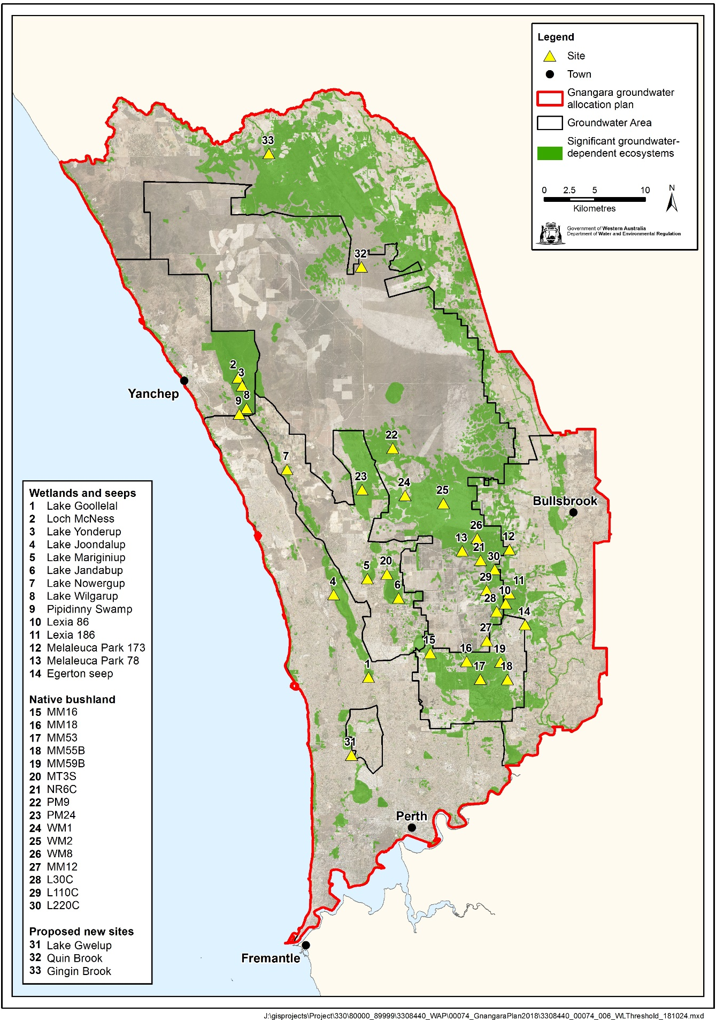

Figure 1 Gnangara groundwater allocation plan area and location of wetland and terrestrial sites investigated in this report.

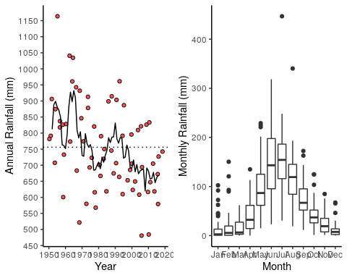

Figure 2 Left: Annual rainfall data reported for Perth Airport (BOM Site 9021) for 1950 - 2018. Red dots represent total rainfall for a given year and dotted line represents average annual rainfall for the entire period. Solid line represents a 5-year moving average of annual rainfall data. Right: Monthly rainfall data reported for Perth Airport (BOM Site 9021) for 1950 - 2018.

# Methodology

The surface geology of the Gnangara Mound reflects processes that have shaped the Swan Coastal Plain over the last two million years due to changing sea levels. These processes determine the soils and sediments of the Swan Coastal Plain, which along with hydrological regimes, are important drivers of the ecology of each wetland. The Gnangara Mound, which is bordered by the 2.5-billion-year-old granite and gneiss of the Darling Scarp in the east, is composed of aeolian, lacustrine, fluvial and estuarine deposits that have created landforms which run parallel to the Scarp and coast. The sediments increase in age from the west coast to the Darling Scarp in the east. The Quindalup Dune System was formed 4,500 to 6,000 years ago (Holocene) and consists of calcareous sand dunes that trend north-south along the coast. Wetlands that occur in the Quindalup Dunes are usually non-groundwater dependent, such as estuaries, and therefore not covered by this report. The Spearwood Dune System is an aeolian calcareous dune system that is the surface expression of the Tamala Limestone formation formed in the Pleistocene. Wetlands are found in the swales of the dunes that run parallel to the coast and are usually elongated in shape. Some of the wetlands are permanently inundated and are deeper than elsewhere on the Gnangara Mound. The Bassendean Dune System is composed of highly permeable white siliceous sands deposited in the middle Pleistocene that are inter-dispersed with areas of poorly drained soils that are subjected to seasonal water logging. Bassendean wetlands typically vary on a theme of circular basin shapes. The wetlands found in each of these dunal systems are largely distinct from one another. For example, Bassendean wetlands generally have tannin rich and acidic waters, and Spearwood waters being clearer and alkaline.

Twenty wetlands from the Bassendean and Spearwood Dune systems are analysed in this report to assess the ecological and managerial impacts of revised groundwater thresholds (Figure 1 and Table 1). [HOW DO THE WANNEROO WETLANDS FIT INTO THIS SYSTEM. NEED TO CONFIRM DUNAL SYSTEMS IN TABLE. GINGIN = Pinjarra Plain?]

Table 1 Summary information of wetlands that have either been systematically surveyed on an annual basis and those that have been sampled for the purposes of this report. For each wetland, information is provided on their morphological properties, the dunal system they are found on, whether systematic surveys of vegetation, aquatic macroinvertebrates and water quality have occurred and their location in the Swan Coastal Plain.

|  |  |  |  |  |  |  |
| --- | --- | --- | --- | --- | --- | --- |
| Wetland | Morphology | Dunal System | Vegetation | Macroinvertebrates | Water Quality | Coordinates |
| Lake Goollelal | Lake | Urban Spearwood Dunes | Annually | Annually | Annually | 31.817°S 115.815°E |
| Loch McNess | Lake | Peri-Urban Spearwood Dunes | Annually | Annually | Annually | 31.548°S 115.682°E |
| Lake Yonderup | Lake | Peri-Urban Spearwood Dunes | Annually | Annually | Annually | 31.555°S 115.686°E |
| Lake Joondalup | Lake | Urban Spearwood Dunes | Annually | Annually | Annually | 31.743°S 115.779°E |
| Lake Mariginiup | Lake | East Wanneroo Interdunal | Annually | Annually | Annually | 31.729°S 115.815°E |
| Lake Jandabup | Lake | East Wanneroo Interdunal | Annually | Annually | Annually | 31.746°S 115.847°E |
| Lake Nowergup | Lake | Peri-Urban Spearwood Dunes | Annually | Annually | Annually | 31.630°S 115.732°E |
| Lake Wilgarup | Was a lake | Spearwood Dunes | Annually | No | No | 31.574°S 115.692°E |
| Pipidinny Swamp | Dampland | Spearwood Dunes | 2019 survey | No | No | 31.580°S 115.683°E |
| Lexia 186 | Sumpland | Bassendean Dunes | Annually | No | No | 31.743°S 115.963°E |
| Melaleuca Park 173 | Lake | Bassendean Dunes | Annually | Annually | Annually | 31.704°S 115.963°E |
| Melaleuca Park 78 | Dampland | Bassendean Dunes | Annually | No | No | 31.704°S 115.915°E |
| MM59B - Whiteman Park East | Terrestrial | Bassendean Dunes | 2019 survey | No | No | 31.804°S 115.954°E |
| PM9 - Pinjar North | Terrestrial | Bassendean Dunes | 2019 survey | No | No | 31.612°S 115.843°E |
| WM1 - Pinjar | Terrestrial | Bassendean Dunes | 2019 survey | No | No | 31.655°S 115.855°E |
| WM2 - Melaleuca Park North | Terrestrial | Bassendean Dunes | 2019 survey | No | No | 31.662°S 115.895°E |
| WM8 - Melaleuca Park | Terrestrial | Bassendean Dunes | 2019 survey | No | No | 31.694°S 115.930°E |
| Lake Gwelup | Lake | East Wanneroo Interdunal | Annually | No | No | 31.878°S 115.791°E |
| Quin Brook | Brook | Bassendean Dunes | Annually | No | No | 31.450°S 115.812°E |
| Gingin Brook | Brook | Bassendean Dunes | No | No | No | 31.348°S 115.717°E |

## 

## Vegetation monitoring

The overall objectives of the wetland vegetation monitoring on the Gnangara Mound are:

* to determine the impact of altered groundwater regimes on the ecological condition of wetland vegetation
* to monitor the condition and composition of fringing vegetation at selected Gnangara wetland sites, and to determine if observed changes to vegetation are associated with changes in groundwater and wetland water levels
* to identify vegetation monitoring parameters relevant to monitoring objectives.

Vegetation is monitored every spring at selected wetland sites. Spring provides the best opportunity to capture the greatest plant diversity as well as enhancing identification as most Swan Coastal Plain flora are in flower. Annual surveys permit direct comparisons of vegetation changes to be made, especially in response to rapidly declining groundwaters.

Extensive methodological details can be found in the annual Wetland Vegetation Monitoring reports (see Buller et al., 2019). The data analysed here primarily deals with the longitudinal cover abundance data set that has been compiled between 1996 and 2018. This data set has been collected by surveying the species present at established transects at each wetland. The standard design of these transects is a series of 3 to 4 10x10 m plots extending from the wetland end (Plot A) to the terrestrial end (generally Plot D). In some instances, when surface water declines are significant, the transect has been extended to include new plots at the current water edge. It is important to note that not every wetland is sampled every year, and some wetlands have gone a number of years since last survey (Figure 3). The vegetation at the wetland Pipidinny Swamp and four terrestrial sites, WM1, WM2, WM8 and Whiteman Park East, were surveyed for the first time this spring (2019). Only a brief description of those sites is given in this report and a more detailed analysis will be given in the 2020 Wetland Vegetation Report.

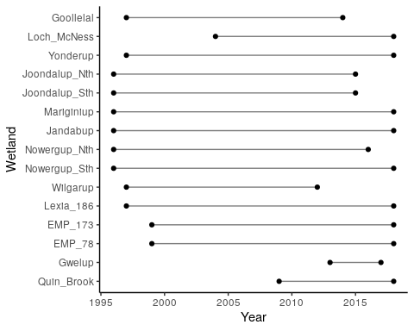

Figure 3 Period of vegetation monitoring for each wetland.

## Aquatic invertebrate monitoring

Data of aquatic macroinvertebrate communities have been compiled during the Gnangara Mound Environmental Monitoring Programme - Macroinvertebrate and Water Quality Wetland Monitoring since 1996 (see Judd and Horwitz (2019) for latest report and comprehensive methodology). The wetlands included in this report where macroinvertebrate data has been collected include Lake Jandabup, Lake Mariginiup, Loch McNess, Lake Nowergup, Lake Yonderup, Lake Goollelal, Lake Joondalup and Melaleuca Park 173. All these wetlands are either permanently or ephemerally inundated.

For each wetland, a series of habitat types are sampled using 250 $μ$ m mesh nets and identified under a microscope to family levels. An abundance score for each taxon is recorded (rare = 1-2 specimens, scarce = 3-10 specimens, common = 11-100 specimens, abundant = 100-1000 specimens and extremely abundant = > 1000 specimens). Sampled habitats are subject to availability, therefore not all habitats can be sampled each year for each wetland. Sampling occurs when spring high water levels are reached for each wetland each year to ensure maximum availability of habitats and potential diversity of macroinvertebrates. For the purposes of this report, sampled habitats for each wetland have been pooled for each year. Nonetheless, the disappearance of habitats when surface water levels are not high enough to make them available, or if habitats disappear due to loss of fringing vegetation, needs to be considered when considering the role of groundwater level on the aquatic ecology of these wetlands.

## Water quality monitoring

## Statistical analyses

Generalised additive models (GAMs) were used to model non-linear trends in water level time series data (Wood, 2011). Historical water level data for each of the wetlands in this report was accessed from the DWER website (<http://www.water.wa.gov.au/maps-and-data/monitoring/water-information-reporting>). To simplify modelling, mean monthly water levels were calculated and used for modelling. A cyclic cubic spline with 12 dimensions was used as a smooth term to ensure there was no discontinuity between January and December water levels. To account for correlated errors, an ARMA process, nested within each year, was fitted to the residuals using the R package *nlme* v 3.1-141 (Pinheiro et al., 2019). All GAMs were fitted using the R package *mgcv* v 1.8-30 (Wood, 2019).

A multivariate analysis was used to explore the effects of ground/surface water level on vegetation communities. This fits a multivariate generalised linear model to the data so that the effects of species covariates (including groundwater level) on each species can be modeled (Hui, 2016). Species abundances (vegetation and macroinvertebrates) were fitted to negative binomial distributions and the models fitted with two latent variables. The models were fitted and unconstrained model-based ordinations were carried out on the macroinvertebrate and vegetation data using the *boral* package v 1.7 (Hui, 2018). The resulting ordinations enable graphical representations of communities for each wetland to be made, with points closer to each other more similar in terms of taxonomic composition than those more distant. Wetland specific boral models were run using the mean fitted water level for each survey year as a covariate in order to understand species specific interactions with water levels. All analyses were conducted using R (version 3.6.1)

# Individual wetland descriptions

This section provides an assessment for each wetland on what effect the proposed absolute minimum threshold water levels will have on the original site management objectives and values as well as possible effects on species composition, key, priority or threatened species and existing ecohydrological states. For each wetland, a description of past hydrological patterns is provided with an emphasis on understanding period of changing hydrological regimes. A summary table is provided that details the ecological consequences of the proposed changes on the site management objectives and values. These summaries are based on a thorough analysis of aquatic macroinvertebrate and wetland vegetation data from systematic annual surveys, when available. The details of these analyses are provided in subsequent subsections detailing patterns of change and predicted future effects for water quality, aquatic macroinvertebrates and vegetation.

## Lake Goollelal

Lake Goollelal, located within the Yellagonga Regional Park, is recognised as an important water bird habitat and drought refuge (Froend, et al., 2004) as well as habitat for the Swan River Goby (*Pseudogobius olorum*) and the Western Pygmy Perch (*Edelia vittata*; Water Authority of Western Australia (1995)). The permanent deep waters found in the lake not only provides significant habitat for fauna and fringing vegetation, but also hold significant value as a place of public enjoyment. The lake is surrounded by a highly urbanised area, with the majority of the lake buffered by a belt of fringing vegetation although some residences are in close proximity to the lake’s margin.

### Hydrology

Surface water levels recorded at Lake Goollelal reveal peak levels generally occur between September and November and lowest water levels between March and May (Table 2). Annually, water levels have consistently varied by about 0.7 m during this period. Since 1995, there has been a general trend of decreasing surface water levels, although recent increases since 2016 show surface water at a similar depth to 1990 levels (Figure 4). Surface water levels show similar trends to groundwater levels at a nearby bore (61611870) as the lake is largely fed by groundwater. Although the preferred minimum threshold of 26.0 mAHD has not been breached, it is likely the threshold is set too low as acidification of waters in the lake is a concern (Quintero Vasquez and Lund, 2018). Proposed changes to the Ministerial Criteria include adopting a higher threshold level of 26.4 mAHD. Based on the modelling, the proposed threshold can be met at 2030.

Table Five year summaries of surface water level data at Lake Goollelal recorded at staff 6162517.

|  |  |  |  |  |
| --- | --- | --- | --- | --- |
| Period | Mean max seasonal  level (mAHD) | Mean min seasonal  level (mAHD) | Mean seasonal change (m) | Mean max to min (days) |
| 08/1994 – 07/1999 | 27.5 (Oct) | 26.8 (May) | 0.78 | 207 |
| 08/1999 – 07/2004 | 27.5 (Sept) | 26.7 (Mar) | 0.80 | 206 |
| 08/2004 – 07/2009 | 27.4 (Sept) | 26.6 (Apr) | 0.75 | 137 |
| 08/2009 – 07/2014 | 27.2 (Oct) | 26.5 (Apr) | 0.73 | 190 |
| 08/2014 – 07/2019 | 27.4 (Nov) | 26.7 (Apr) | 0.68 | 139 |

### Site summary

The proposed reductions in groundwater suggest that the current hydrological regime can be maintained. Adopting a minimum threshold of 26.4 mAHD (0.4 m higher than current threshold) will minimise the risk of acidification at Lake Goollelal. Under the 2030 scenario, vegetation composition is likely to remain distinct across the elevations of the basin, with *B. articulata* and *Lepidosperma gladiatum* persisting along the lake margin. The richness of exotic plant species in the higher areas of the basin are likely to persist or decline if surface water levels remain at, or greater than, present levels. Similarly, it is expected that the aquatic invertebrate community will remain stable as fringing vegetation preserves habitat availability and water quality.

Revised thresholds will likely maintain ecological conditions similar to present (

Table 3). The most important impact of the revised thresholds is that it will ensure water levels remain at, or higher than, present levels which has positive implications for habitat availability and risk of acidification. The sustenance of permanent water will ensure that Lake Goollelal acts as a drought refuge for water birds, with seasonal fluctuations in water levels ensuring feeding habitats are available for waders during the summer months. The preservation of fringing vegetation, submerged macrophytes and deep water will also ensure the wetland continues to support important native fish species (*P. olorum* and *E. vittata*), a feature becoming rarer among wetlands in the Swan Coastal Plain. Conservation of these values will maintain the site as a place for public enjoyment and maintain the current landscape amenity values.

Table 3 Ecological consequences of revised thresholds in terms of compliance of stated site values and site management objectives at Lake Goollelal.

|  |  |  |
| --- | --- | --- |
|  | Likely effect of 2030 revised thresholds | Future Compliance |
| **Site values** |  |  |
| * Water bird habitat and drought refuge | Permanent water will ensure site as drought refuge. Seasonal variation in water levels will preserve feeding habitats | Likely |
| * Supports good populations of native fish species, Swan River goby (*Pseudogobius olorum*) and the western pygmy perch (*Edelia vittata*) | Maintenance of deep waters, fringing vegetation, submerged macrophytes and water quality will ensure the wetland remains an important habitat for these fish species | Likely |
| **Site management objectives** |  |  |
| * Conservation and public enjoyment of natural and modified landscapes | Fringing vegetation and woodlands will remain healthy and the site will continue to provide habitat for fauna. The site will continue to remain a place of public enjoyment. | Likely |
| * Protect and if possible enhance, fringing wetland vegetation including woodland and sedge vegetation | Maintenance of surface water levels at, or slightly higher than, current levels will ensure that woodland and sedge vegetation remain healthy. The distribution of sedges may increase slightly | Likely |
| * Maintain permanent, deep water for water bird habitat and as a drought refuge | Current projections ensure that permanent and deep water will remain a feature of the wetland. The capacity of the wetland to act as a drought refuge will continue. | Likely |
| * Maintain permanent water for fish and other dependent species | Current projections ensure that permanent and deep water will remain a feature of the wetland. Permanent water will preserve fish habitat and water quality. | Likely |
| * Maintain the landscape amenity values of the wetland | Healthy vegetation and abundant bird life will remain a feature of the wetland if water levels are sustained at current levels, ensuring the amenity values of the wetland. | Likely |

### 

### Water quality

Lake Goollelal has stable water quality (Judd and Horwitz, 2019). Water pH, normally around 7.5, has only been recorded below 7 in 2007 while the current risk of acidification remains low due to declining chloride:sulphate. Currently, the lake has low phosphorous, but is experiencing increasing levels of nitrogen, although levels are still below long-term averages.

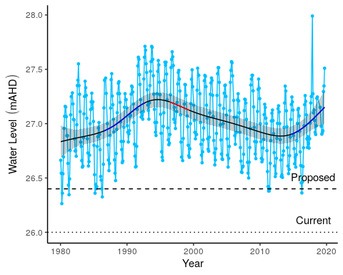

Figure 4 Surface water levels recorded at staff 6162517 for Lake Goollelal. Red segments on fitted line represent statistically significant periods of declining water levels and blue segments represent statistically significant periods of increasing water levels. Dotted line is the current ministerial absolute minimum water levels. Dashed line is the proposed 2030 minimum threshold level.

### Vegetation dynamics

The composition of vegetation at Lake Goollelal has been assessed 15 times between 1997 and 2019 at four plots along an established transect. Plot A represents fringing *Melaleuca rhaphiophylla*/*Eucalyptus rudis* vegetation and a stable community of the native sedges, *Baumea articulata* and *Lepidosperma gladiatum*. The *M. rhaphiophylla*/*E. rudis* complex continues throughout the transect, which has also remained relatively stable in terms of cover abundance since 2002. There is a high richness of exotic vegetation species present at the lake. Generally, these exotic species have increased in abundance during the survey period.

Ordination reveals that Plot A has a distinct assemblage to the other plots but has displayed similar shifts in vegetation composition during the monitoring period (Figure 5). All plots show minor shifts in composition during the study period, with each plot be distinct from the others. Plot D displays a different pattern, probably due to the record of *B. articulata* in 1997 and the high cover abundance of exotic species. Bayesian regression analysis predicts many exotic species to increase in cover abundance with declining surface water levels (Figure 6).

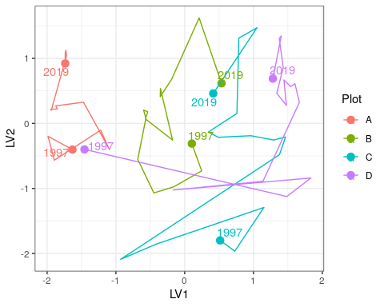

Figure 5 Unconstrained ordination based on vegetation data for each surveyed year for Lake Goollelal. Plots are represented as different colours and consecutive years are joined by a line with first and last survey years labeled.

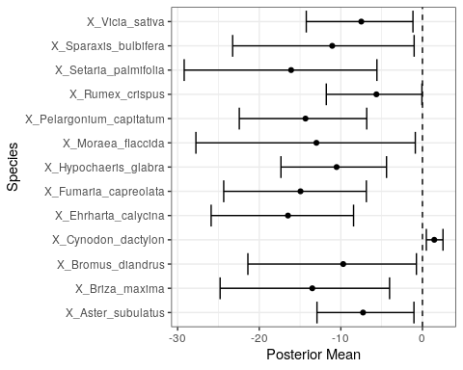

Figure 6 Estimated mean regression coefficients (dots) and 95% credible intervals (bars) for effect of groundwater levels at Melaleuca Park 78 on vegetation species cover abundances based on Bayesian Regression Analysis (HUI REF 2015). Species with a negative mean posterior value are likely to increase in cover abundance as water levels decline while species with positive posterior values are likely to increase in cover abundance with increasing water levels. Only those species with coefficients significanlty different to zero are shown.

### Aquatic invertebrates

The mean family richness of aquatic invertebrates is 22 for Lake Goollelal (Figure 7). Since 2008, family richness has mostly been stable and above the long term average. There are stable populations of Amphisopidae, Calanoida, Ceinidae, Chironominae, Corixidae, Cyprididae and Amphisopidae at the lake. Other taxa are not currently recorded in the lake include Ceratopogonidae, Chydoridae, Oligochaeta and Pionidae. The absence of the Chydoridae (Cladocera) is notable given the abundance in early monitoring years. There was a major shift in the assemblage composition in 2006-2007, with ordination revealing two main groups of annual data; those collected pre 2007, and those collected post 2007 (Figure 8). However, recent high water levels and low nutrients appear to shifting the assemblages back towards pre-2007 compositions (see Judd and Horwitz (2019)).

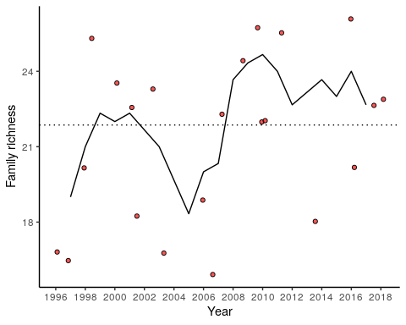

Figure 7 Richness of aquatic invertebrate families for each year at Lake Goollelal. Line is a moving 3-year averavge.

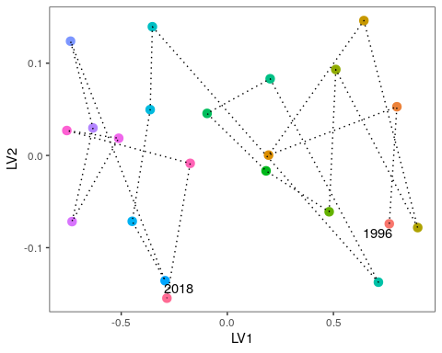

Figure 8 Unconstrained ordination based on invertebrate data for each surveyed year for Lake Goollelal. Consecutive years are joined by a line with first and last survey years labeled.

## Loch McNess

Loch McNess, located in Yanchep National Park, is a relatively undisturbed wetland with large areas of intact Herdsman Complex vegetation. The lake has had relatively good water quality and provides an important habitat for water birds and other aquatic fauna (R Froend, et al., 2004). Permanent water is required to support a local Rakali (*Hydromys chrysogaster*) population as well as both resident and visiting populations of waterbirds and waders. The southern lake at Loch McNess is one of the few wetlands known to contain the nightfish *Bostokia porosa* and has one of the richest aquatic macroinvertebrate communities of the Swan Coastal Plain. Loch McNess is a wetland of high conservation value because of its intact vegetation, largely unaltered aquatic processes and important populations of fauna (R Froend, et al., 2004).

### Hydrology

Since early 2011, readings for the staff gauge (6162564) at Loch McNess have frequently been below the gauge’s limit. It is therefore likely the decline in surface water levels have continued pasted the levels shown in Figure 9. Nonetheless, surface water, which were remarkably stable before 2003 at 7 mAHD, have declined at least 1.5 m to present levels. These declines have been mirrored in surrounding bores (Figure 9). Mean maximum and minimum seasonal water levels have decline by 0.9 m since 1994-2004 levels (Table 4). Changes in seasonal patterns are difficult to interpret due to staff gauge 6162564 being mostly dry since 2014, but during the period 2009-2014, minimum water levels were not being reached until May, compared to March in the decade 1994-2004. A recent increase in water level, as seen in surrounding wetlands during the last few seasons, has not been observed at Loch McNess. The dramatic decline in water levels is causing the terrestrialisation of the lake as much of the lakebed is now undergoing recruitment by fringing vegetation.

The lake has been non-compliant with ministerial water levels since 2003 and water levels are now approximately 1.0 m below this threshold. Modelling of groundwater levels under proposed abstraction reductions will not provide sufficient increases in groundwater to make this wetland compliant with existing thresholds. Under the new plan, a proposed threshold of 8.0 mAHD at bore 61612104 will satisfy the proposed threshold of surface waters in the lake at 6.2 mAHD (0.75 m below existing threshold).

Table 4 Five year summaries of surface water level data at Loch McNess

|  |  |  |  |  |
| --- | --- | --- | --- | --- |
| Period | Mean max seasonal  level (mAHD) | Mean min seasonal  level (mAHD) | Mean seasonal change (m) | Mean max to min (days) |
| 08/1994 – 07/1999 | 7.1 (Sep) | 7.0 (Mar) | 0.11 | 123 |
| 08/1999 – 07/2004 | 7.1 (Jul) | 6.9 (Mar) | 0.12 | 91 |
| 08/2004 – 07/2009 | 7.0 (Jun) | 6.8 (Feb) | 0.21 | 131 |
| 08/2009 – 07/2014 | 6.5 (Oct) | 6.2 (May) | 0.31 | 229 |
| 08/2014 – 07/2019 | 6.2 (Dec) | 6.1 (Jul) | 0.11 | 25 |

### Site summary

Managing the lake at the proposed threshold (0.75 m below the current threshold) will continue the deterioration of site values at Loch McNess (

Table 5). Extraterrestrial of large areas of once inundated lake bed will continue, nutrient levels may stay elevated and important habitats for Rakali may be lost. The characteristic stable water levels have been severely disrupted by a changing hydrological regime, and the proposed threshold will not manage surface water at a sufficient level to return to this state. Altered ecological processes have caused shifts in nutrient levels and the composition of macroinvertebrate assemblages. Again, these features of Loch McNess are unlikely to return to normal given the proposed lowering of threshold levels.

Table 5 Ecological consequences of revised thresholds in terms of compliance of stated site values and site management objectives at Loch McNess.

|  |  |  |
| --- | --- | --- |
|  | Likely effect of 2030 revised thresholds | Future Compliance |
| **Site values** |  |  |
| * Undisturbed wetland | Sustained low water levels will continue to cause a shift in vegetation composition as once inundated regions of the lake become terrestrialised. The disappearance of *B. articulata*, an important fringing sedge, marks a significant change in composition of the wetland vegetation. | Unlikely |
| * Unusual hydrologic regime | Surface water levels appeared to reach a tipping point in 2003. There has been significant disruption of once stable water levels which will not return to normal under predicted reduced abstraction | No |
| * Rich aquatic fauna | Declining water levels has not disrupted the richness of the aquatic invertebrate assemblage. However, there has been an associate shift in the composition of the lake assemblage. The proposed thresholds will prevent the assemblage returning to pre-2003 composition, and instead will sustain an assemblage composed of common taxa and nuisance species. | Disrupted |
| * Vegetation largely intact, provides a range of habitat types | The health of fringing *M. rhaphiophylla* and *E. rudis* appears good, despite the lower water levels. Loss of *B. articulata* will alter fringing fauna habitat. Loss of islands in lake may affect the Rakali population. | Likely |
| * Supports good populations of water birds and acts as a drought refuge | Revised threshold will sustain permanent water at the site. Permanent water is fundamental to the lake acting as a drought refuge for birds. | Yes |
| * Excellent water quality |  | No |
| **Site management objectives** |  |  |
| * Maintain the environmental quality of the lake |  |  |
| * Maintain North Loch McNess’ pristine state |  | No |
| * Continue to use south Loch McNess for low key recreation |  |  |
| * Maintain east Loch McNess in a natural state, to restore, where possible, natural flow |  |  |
| * Maintain the existing hydrological regime | The loss of stable water levels (once a characteristic of the lake) has deteriorated to the point where water levels have declined more than 1.0 m and are susceptible to further declines under a drying climate despite the revised thresholds. | No |

### 

### Water quality

Water quality at Loch McNess appears to have stabilised in the past couple of years. Normal pH is thought to be over 8.0 but has been below 8.0 since 2010. Current monitoring suggests a pH of 7.8, the highest since 2010 (Judd and Horwitz, 2019). Chloride:sulphate and alkalinity observations suggest that acidification is not a concern at the wetland. There has been a trend of increasing nitrogen levels in the wetland since 2010, but this trend has not continued for 2017-2018 despite current levels being double 1997-2007 levels. Current phosphate levels are an order of magnitude greater than 1999-2004 levels and require close monitoring.

### Vegetation dynamics

A vegetation monitoring transect was established in 2004 with three plots (A, B, and C) plus an additional up-slope plot in 2009 (Plot D) and a plot down-slope of Plot A in 2010 (Plot E). The fringing vegetation is largely comprised of a *Melaleuca rhaphiophylla*/*Eucalyptus rudis* complex. Most trees are in average to good health (Buller et al., 2019). *Baumea juncea* is found in Plots A - D at relatively constant cover abundances. *Baumea articulata*, however, disappeared from Plot A in 2005 and was present in the new down-slope plot (Plot E) until 2014. Currently, *B. articulata* is probably not present at the site (Buller 2019 - personal observation) and the disappearance is likely due to a combination of a fire in 2009 and declining water.

Plots A and B have shifted in community composition dramatically during the monitoring period as the vegetation responds to lower surface water levels in the lake and the impact of fire in 2004 and 2009 (Buller et al. (2019); Figure 10). Regression analysis reveals that the exotic *Avena barbata* and the native *Tricoryne elatior* will increase the most in cover abundance as water levels in the lake remain low or decline further (Figure 11). The natives, *Carex fascicularis*, *Triglochin centrocarpa* and *M. rhaphiophylla* are most likely to decline dramatically at the wetland under a scenario of continued low water levels.

### Aquatic macroinvertebrates

Loch McNess is the most taxonomically rich of the Spearwood Dune wetlands, with about 27 macroinvertebrate families regularly found there (Figure 12). However, the composition of the community is shifting (Figure 13). The communities were relatively stable in terms of composition until 2008 when water levels began to decline significantly. The current trajectory suggests the dissimilarity between pre-2008 and contemporary communities will continue. The site is now dominated by common taxa of the Swan Coastal Plain such as Amphisopidae, Chironomidae larvae, Corixidae, Culicidae larvae, Cyclopoida (*Daphnia*), Dytiscidae, Notonectidae and Pionidae. Some of these, namely Chironomidae and Culicidae larvae, are considered nuisance species. The Amphipod, Ceinidae, has not been collected in the lake since 2014 and the shrimp *Palamonetes australis* not recorded since 2010. This shift in macroinvertebrate assemblage indicates serious changes in ecological processes as the wetland transitions towards a nutrient enriched shallow lake.

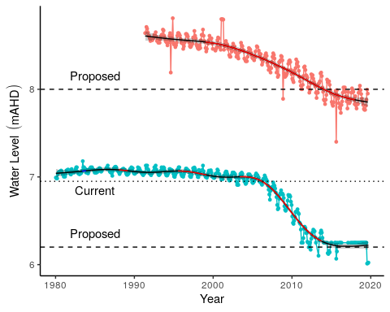

Figure 9 Ground and surface water levels recorded at bores 61612104 (red) and staff gauge 6162564 (blue) that represent changes in water levels at Loch McNess. Segments in red represent periods of significant decline in water level. Dotted line is the current ministerial threshold water level for surface waters at the staff gauge. Dashed lines are proposed ministerial thresholds for the staff gauge and bore.

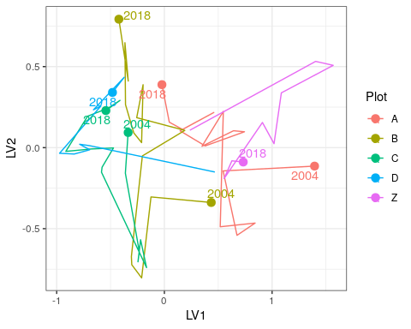

Figure 10 Unconstrained ordination based on the latent variable model for each surveyed year for Loch McNess. Plots are represented as different colours and consecutive years are joined by a line with first and last survey years labeled.

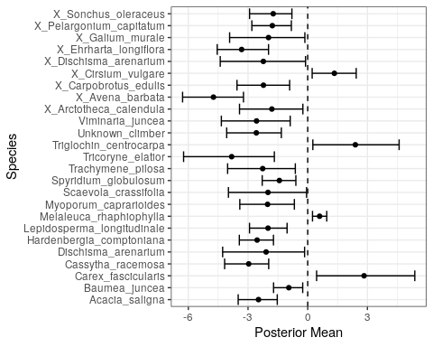

Figure 11 Estimated mean regression coefficients (dots) and 95% credible intervals (bars) for effect of groundwater levels at Loch McNess on vegetation species cover abundances based on Bayesian Regression Analysis (HUI REF 2015). Species with a negative mean posterior value are likely to increase in cover abundance as water levels decline while species with positive values are predicted to increase in cover abundance with water increasing water levels. Only those species with coefficients significantly different to zero are shown.

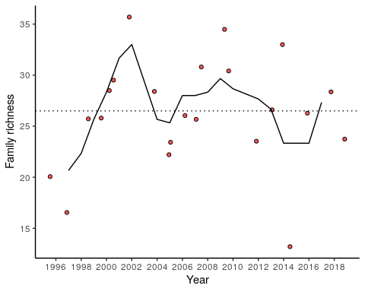

Figure 12 Richness of aquatic invertebrate families for each year. Line is a moving 3-year average at Loch McNess.

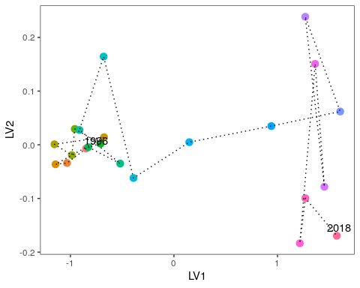

Figure 13 Unconstrained ordination based on invertebrate data for each surveyed year for Loch McNess. Consecutive years are joined by a line with first and last survey years labeled.

## Lake Yonderup

Located to the south of Loch McNess and north of Lake Wilgarup in Yanchep National Park, Lake Yonderup has a high conservation value as it represents a largely undisturbed wetland with high macroinvertebrate richness and excellent water quality. The permanently filled lake is dependent on groundwater to maintain habitats and biophysical processes (R Froend, et al., 2004). Like other lakes in the region, Lake Yonderup has experienced a consistent decline in surface water levels that has affected the condition and health of fringing vegetation and aquatic processes. A fire also effected the fringing vegetation in 2004/2005 (Rogan et al., 2006).

### Hydrology

There has been a continual decline in surface water levels at staff gauge 6162565 since 1994. Prior to 1994, water levels were relatively stable at 6 mAHD but have since declined to approximately 5.3 mAHD (Figure 14). There has been no increase in surface water levels with recent high rainfall seasons. Mean maximum and minimum seasonal water levels have only declined 0.2 and 0.3 m, respectively from 1994-1999 levels (Table 6). There has been nearly a fourfold increase in seasonal water level variation and waters are generally now in decline for more than 200 days a year. The bore 61611840 is located near the vegetation transects and represents the groundwater levels in the superficial aquifer that the vegetation at the transect is utilising. There has been a similar decline in groundwater levels at this bore until 2017, although observations have only been recorded since 2008. Therefore surface water levels are used to assess changes in vegetation as surface water is likely an expression of the superficial aquifer and show similar trends (R Froend, et al., 2004). The current ministerial minimum threshold is 5.9 mAHD while the 2030 proposed threshold is 5.7 mAHD. The lake has been non-complaint with the current threshold since about 2004. Slight increases in surface water levels are required to meet the proposed threshold.

Table 6 Five year summaries of surface water level data at Lake Yonderup

|  |  |  |  |  |
| --- | --- | --- | --- | --- |
| Period | Mean max seasonal  level (mAHD) | Mean min seasonal  level (mAHD) | Mean seasonal change (m) | Mean max to min (days) |
| 08/1994 – 07/1999 | 6.0 (Aug) | 5.9 (Sep) | 0.07 | 82 |
| 08/1999 – 07/2004 | 6.0 (Sep) | 5.9 (Feb) | 0.06 | 144 |
| 08/2004 – 07/2009 | 5.9 (Apr) | 5.9 (Apr) | 0.06 | 130 |
| 08/2009 – 07/2014 | 5.9 (Sep) | 5.7 (Apr) | 0.19 | 212 |
| 08/2014 – 07/2019 | 5.8 (Sep) | 5.6 (Mar) | 0.25 | 218 |

### Site summary

Managing the lake at the proposed 2030 thresholds may alleviate some of the effects of declining surface waters at Lake Yonderup (

Table 7). Higher water levels may improve the cover abundances of many native plant species; however, it is unknown whether the proposed increases in surface water are sufficient to achieve this. Like Loch McNess, the remarkably stable surface water levels were a feature of this wetland and have now been compromised by declining water levels and increased seasonal variation. As no vegetation transects exists at the lake’s margin, it can only be speculated that without any effort to reduce the seasonal variation in surface water levels to the small fluctuations characteristic of the lake before 2004, fringing vegetation will be dominated by sedges capable of surviving periods without surface water. Combined with stable surface waters higher than present, and the continuation of stable water quality, it is also likely that sustaining water levels at the proposed threshold will halt the decline in macroinvertebrate richness of the lake as habitats currently unavailable to aquatic invertebrates become available again.

Table 7 Ecological consequences of revised thresholds in terms of compliance of stated site values and site management objectives at Lake Yonderup.

|  |  |  |
| --- | --- | --- |
|  | Likely effect of 2030 revised thresholds | Future Compliance |
| **Site values** |  |  |
| * High ecological values due to undisturbed nature | Terrestrial regions of the site are currently dominated by exotic vegetation, with concerning declines in key native species. Further declines will exacerbate the decline of native vegetation. Native species may become more abundant post 2030 when higher water levels are achieved. Continuation of stable water quality and low nutrient state are likely to maintain the current composition of aquatic macroinvertebrates. The proposed thresholds increase the likelihood of maintaining this distinctive community. The stable hydrological regime is unlikely to return. | Likely |
| * Rich invertebrate fauna | Higher than present surface waters, combined with maintenance of water quality conditions are likely to have a positive impact on aquatic macroinvertebrate assemblages. There has not been an observed dramatic shift in assemblage structure since 1996. | Likely |
| * Excellent water quality | Sustaining surface waters greater than current levels will reduce the risk of acidification, which is currently low. There are indications that nutrient levels may be on the rise and any further declines in water level before the 2028 may cause shifts in the ecosystem functioning of the lake. | Likely - dependent on no further declines in water levels before 2028 |
| * Undisturbed hydrologic regime and lack of seasonal variation | Seasonal variation has increased with declining water levels. Unlikely that this feature will return unless water levels return to pre-2004 levels. | Unlikely |
| * *Banksia* woodland <8m depth to groundwater | There are currently few mature *B. littoralis* at the site and only a few, albeit healthy, seedlings in the transect. Mature woodland was destroyed by bushfire in 2004/05 and has not since recovered. Achieving water levels higher than current levels will facilitate recruitment and recovery. | Possible - dependent on future bushfire impacts |
| **Site management objectives** |  |  |
| * Maintain the environmental quality of the lake | Many exotic vegetation species are likely to persist, particularly if water levels decline further before 2028. If nutrient levels remain low, it is likely that the aquatic invertebrate assemblage will remain like the current assemblage. | Likely |
| * Maintain the existing hydrological regime | The hydrological regime has been disrupted since the 2003 declines in surface water levels. In particular, the lack of seasonal variation is a key feature of this wetland that is unlikely to return unless water levels are compliant with the existing threshold (5.9 mAHD). | Unlikely |

### 

### Water quality

Lake Yonderup has the lowest nutrient levels of all the monitored wetlands on the Gnangara Mound (Judd and Horwitz, 2019), however, the most recent observations for 2018 indicate that total nitrogen levels may be increasing. Otherwise, the water chemistry of the lake has remained relatively stable. Stable alkalinity and a pH that consistently remains above 7.0 suggests there is little risk of acidification.

### Vegetation dynamics

The vegetation transect, established in 1997, is located 750 m south of the basin and is therefore not representative of vegetation at the wetland itself. The lake provides habitat for *Baumea articulata* although there is recent evidence of *Typha orientalis* invading the wetland (Judd and Horwitz, 2019). At the vegetation monitoring transects, the site was reported to have a rich exotic community before monitoring began in 1997 and this characteristic of the site has persisted. Currently, exotics account for 60% of the cover abundance and native richness has been declining (Buller et al., 2019). The shifts in vegetation composition at each plot suggest vegetation has changed dramatically since 1997 but largely stabilised in the late 2000’s (Figure 15). There was a dramatic shift in vegetation composition after the 2004/2005 fire which also coincided with an increase in the rate of decline of surface waters. All the native species, including *Banksia attenuatta* and *Melaleuca preissiana*, are likely to decline in cover abundance under a scenario of sustain low water levels or further declining groundwaters (Figure 16). In fact, *B. attenuatta* and *M. preissiana* have already disappeared from the monitoring transect, while stands of *Melaleuca rhaphiophylla* are unhealthy.

### Aquatic macroinvertebrate community

Taxonomic richness of the macroinvertebrate assemblage in Lake Yonderup has been declining since 2012 (Figure 17). Richness is now lower than previous records and the trend may suggests some shifts in ecological processes due to declining water levels. The composition of the Lake Yonderup macroinvertebrate community is variable (Figure 18). Many taxa are not recorded every year, or are absent for periods, such as Ceinidae, Oligochaeta and Orthocladiinae. Other taxa have declined, or perhaps become locally extinct, including Dytiscidae and Hydrophilidae. Chironominae, Cyclopoida, Cyprididae and Leptoceridae have been recorded in nearly every sampling event at Lake Yonderup.

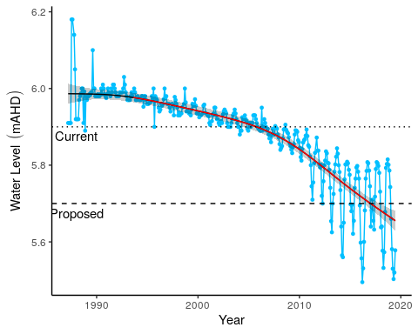

Figure 14 Surface water levels recorded at staff gauge 6162565 for Lake Yonderup. Red segments along trendline indicate periods of significant decline in groundwater levels and blue segments represent significant increases in groundwater level.

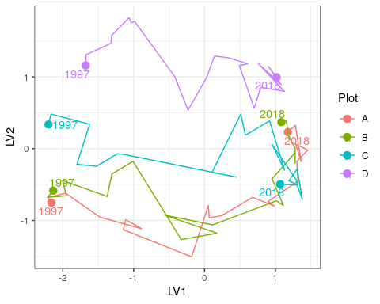

Figure 15 Unconstrained ordination based on the latent variable model for each surveyed year for Lake Yonderup. Plots are represented as different colours and consecutive years are joined by a line with first and last survey years labeled.

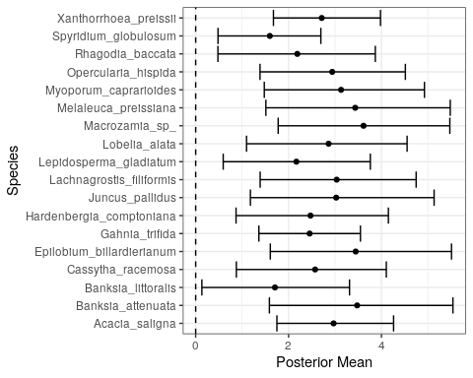

Figure 16 Estimated mean regression coefficients (dots) and 95% credible intervals (bars) for effect of groundwater levels at Lake Yonderup on vegetation species cover abundances based on Bayesian Regression Analysis (HUI REF 2015). Species with a negative mean posterior value are likely to increase in cover abundance as water levels decline. Only those species with coefficients significantly different to zero are shown.

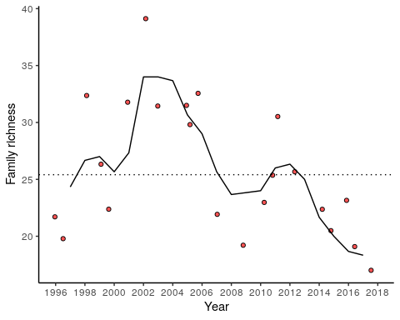

Figure 17 Richness of aquatic invertebrate families for each year at Lake Yonderup. Line is a moving 3-year average.

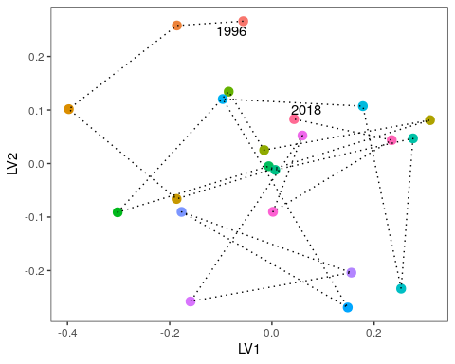

Figure 18 Unconstrained ordination based on invertebrate data for each surveyed year for Lake Yonderup. Consecutive years are joined by a line with first and last survey years labeled.

## Lake Joondalup

At 611.5 ha, Lake Joondalup is the largest monitored wetland and is managed by the Department of Biodiversity, Conservation and Attractions. The lake is an important habitat and drought refuge for water birds, and in conjunction with Lake Goollelal, is managed to support the full range of avian habitats (Water Authority of Western Australia, 1995). Other management objectives include the conservation of diverse wetland vegetation communities, including sedge beds, fringing woodlands and aquatic macrophytes, and the maintenance or enhancement of aquatic fauna in the lake. Lake Joondalup supports an important population of Pygmy Perch (*Edelia vittata*) and Swan River Goby (*Pseudogobius olorum*) and the fringing woodlands and bushland support a variety of significant mammal species.

### Hydrology

Lake Joondalup has remained permanently inundated at the staff gauge since 1986 (Horwitz et al., 2009). However, vast regions of the basin dry most summers and provide habitat for visiting water birds. Recent monitoring of surface water levels at the staff gauge 6162572 remained relatively stable from 2002 but have been increasing from 16.4 mAHD to approximately 17.2 mAHD in 2019 (Figure 19). Five-year summaries of hydrological regimes at Lake Joondalup also reveal the higher mean minimum and maximum surface water levels in the latest period compared to earlier periods, as well as an increase in the number of days to reach seasonal minimum water levels (Table 8). Historically, groundwater levels at monitoring bore 61610661 declined significantly by 1.2 m from 1970 to 2002. Currently, groundwater levels at this bore, as well as bore 61611423 (likely to better reflect lake surface water variation), have been increasing since 2015 to levels similar to the early 1990s.

Table 8 Five year summaries of surface water level data at Lake Joondalup

|  |  |  |  |  |
| --- | --- | --- | --- | --- |
| Period | Mean max seasonal  level (mAHD) | Mean min seasonal  level (mAHD) | Mean seasonal change (m) | Mean max to min (days) |
| 08/1994 – 07/1999 | 17.2 (Sep) | 16.2 (Apr) | 0.96 | 213 |
| 08/1999 – 07/2004 | 17.0 (Oct) | 16.1 (Apr) | 0.92 | 179 |
| 08/2004 – 07/2009 | 16.9 (Oct) | 16.1 (Apr) | 0.79 | 181 |
| 08/2009 – 07/2014 | 16.9 (Oct) | 16.1 (Mar) | 0.82 | 173 |
| 08/2014 – 07/2019 | 17.2 (Oct) | 16.5 (Apr) | 0.68 | 206 |

### Site summary

The water levels in the vicinity of Lake Joondalup are expected to increase up to 2.1 m by 2030 from 2013 levels based on the revised groundwater allocations. This increase in water level will continue the increasing trend being observed in the lake’s surface water levels since 2015. Maintaining surface water levels above 16.2 mAHD at staff 6162572 will ensure permanent water habitat for fauna and flora and the visual amenity of the area (

Table 9). The diverse macrophytes inhabiting plot A and B of both transects are likely to persist and continue to provide a rich habitat for aquatic invertebrates. Although important native macrophytes and wetland species are likely to continue at relatively high cover abundances under the future scenario, there are some native species that are likely to decrease in cover abundance or disappear. This group mainly includes *Acacia* and *Banksia* species which provide important habitat for fauna up-slope of the lake. Further vegetation monitoring is required at these transects to determine vegetation compositional changes since 2015 to understand if the trajectory in compositional change is continuing.

Table 9 Ecological consequences of revised thresholds in terms of compliance of stated site values and site management objectives at Lake Joondalup.

|  |  |  |
| --- | --- | --- |
|  | Likely effect of 2030 revised thresholds | Future Compliance |
| **Site values** |  |  |
| Water bird habitat and drought refuge | The proposed increases in groundwater levels around the lake will ensure the site remains an important water bird habitat. The proposed increases will also ensure the lake is permanently inundated, which will ensure the lake is a drought refuge for water birds. Seasonal variation in surface water height will also ensure expansive mudflats, an important feeding habitat for many visiting birds, remain. | Very likely |
| Diverse range of macrophytes | The current diversity of macrophytes, including *B. articulata*, *B. juncea* and *L. longitudinale*, will continue. There is the possibility of these species extending into current terrestrial regions of the lake. | Very likely |
| **Site management objectives** |  |  |
| Conservation and public enjoyment of natural and modified landscapes | The wetland should retain the current natural and modified assets. | Very likely |
| Conserve existing wetland vegetation, including sedge beds, fringing woodland and aquatic macrophytes | The predicted increases in groundwater levels will ensure the current wetland at a state similar to 2015. It is possible that sustained increases in groundwater levels will extend the range of these species around the lake by ‘migrating’ up slope. | Very likely |
| Maintain and if possible, enhance the aquatic fauna of the lake | Aquatic vertebrates, including native fish, are likely to persist in the lake, given that permanent inundation will remain a feature of the lake. Although acidification is unlikely, there are issues around water quality and nutrient enrichment. If nutrients continue to rise, local extinctions of fish populations may occur. There are already unusual trends in macroinvertebrate diversity occurring which may be early warnings of significant ecological shifts that may occur due to nutrient enrichment |  |
| In conjunction with Lake Goollelal, to support the full range of habitats for avian fauna | The maintenance of permanent surface water and wetland vegetation will continue to provide a diverse habitat for different avian species. Extensive mudflats should continue to form during periods of low water level, which are also an important feeding habitat for birds. | Very likely |
| Ensure the landscape and amenity values of the lake are maintained, except under very low rainfall climatic conditions | NOT SURE HOW TO COMMENT ON THIS | Very likely |

### 

### Water quality

Recent monitoring suggests pH has been increasing from 6.8 in 2016 up to 8.4 in 2018, probably attributable the higher water levels (Judd and Horwitz, 2019). The lake often has the lowest levels of acidity and highest alkalinity of all the monitored wetlands. Total nitrogen and phosphorus levels have been high in Lake Joondalup, which is now typical of Spearwood dune lakes in modified urban landscapes.

### Vegetation Dynamics

Vegetation surveys have been conducted along a northern and southern transect at Lake Joondalup since 1996 and were last surveyed in 2015. *Melaleuca raphiophylla* dominates the overstory of plots in the northern transect while exotic species are abundant in the understory vegetation. There has been an increasing trend in cover abundance of the exotics *Bromus diandrus*, *Ehrharta longiflora*, *Euphorbia terracina*, *Fumaria muralis* and *Peargonium capitatum* in recent years. Fires in 2003 reduced the canopy condition and abundance of *M. raphiophylla* in the southern transect, and despite the slightly higher cover abundance of native species, native and exotic species richness is equal along the transect. The site also contains healthy stands of *Baumea articulate* in the submerged regions of the transect.

All plots in both transects have displayed similar trends in community compositional change during the survey periods (Figure 20). In the southern transect, ordination reveals separation of the plots along the first axis, with a general temporal trend along the second axis, except for a period around 2003 - 2006 where there was a hiatus. This hiatus may be associated with the 2003 bushfire and represents a recovery period where species composition changed little. The trajectory for plot A is different, however, as the trend away from the original 1996 survey has reversed and the contemporary community is now becoming more like the 1996 communities. Similar patterns have been observed in the northern transect despite the transect not being impacted by the 2003 fire event. A number of native species are likely to increase in cover abundance at the transects if water levels remain at present levels or increase further, including *Baumea articulata* (Figure 21). Other natives are likely to decline in cover abundance under a similar scenario of high-water levels, including a number of *Acacia saligna*, *Banksia menziesii* and *Banksia prionotes*.

### Aquatic Invertebrates

Aquatic invertebrates have been sampled from Lake Joondalup every year since 1996. During this period, 16-30 families of aquatic invertebrates have been recorded per sampling event, except for the latest round in 2018 where family richness was only nine (Figure 22). This exceptionally low family richness was likely due to the lack of insects and associated parasitic mites among the sampled communities. The phreatoicid isopod *Amphisopus palustris* was also absent in 2018 despite being collected every spring in Lake Joondalup (except 2004). Furthermore, this reduced richness occurred during a period of relatively high surface water levels, suggesting other anthropogenic factors may be responsible for the decline of insect fauna within the lake. Otherwise, the lake hosts abundant populations of Ceinidae (amphipods), *Palaemonetes australis* (crustacean), *Calanoid copepods* and Cyprididae (ostracods). There is high variation in the composition of annual macroinvertebrate community composition making it difficult to interpret a trajectory of compositional change (Figure 23). There has been a general trend of community composition shifting away from the initial 1996 community.

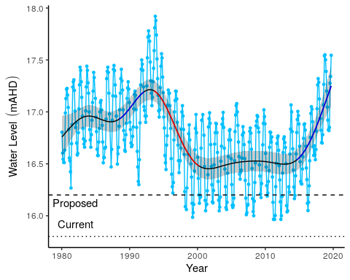

Figure 19 Surface water levels recorded at staff gauge 6162572 for Lake Joondalup. Red segments along trendline indicate periods of significant decline in groundwater levels and blue segments represent significant increases in groundwater level.

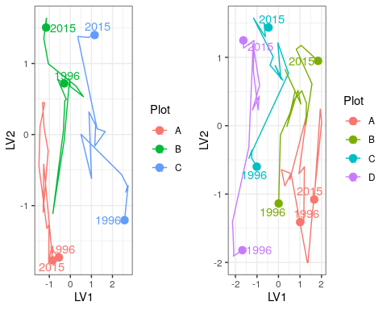

Figure 20 Unconstrained ordination based on the latent variable model for each surveyed year for the northern (left) and southern (right) Lake Joondalup transects. Plots are represented as different colours and consecutive years are joined by a line with first and last survey years labeled.

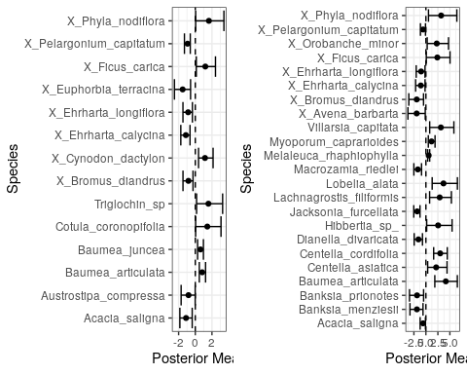

Figure 21 Estimated mean regression coefficients (dots) and 95% credible intervals (bars) for effect of groundwater levels at the northern (left) and southern (right) Lake Joondalup transects on vegetation species cover abundances based on Bayesian Regression Analysis (HUI REF 2015). Species with a negative mean posterior value are likely to increase in cover abundance as water levels decline and species with positive values are likely to increase in cover abundance when water levels increase. Only those species with coefficients significantly different to zero are shown.

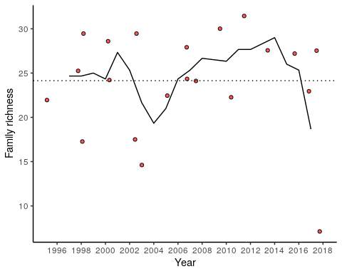

Figure 22 Richness of aquatic invertebrate families for each year at Lake Joondalup. Line is a moving 3-year average.

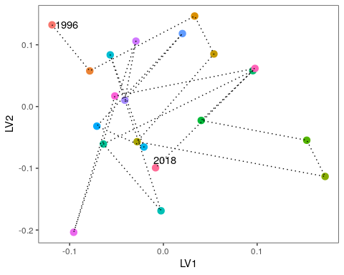

Figure 23 Unconstrained ordination based on invertebrate data for each surveyed year for Lake Joondalup. Consecutive years are joined by a line with first and last survey years labeled.

## Lake Mariginiup

Lake Mariginiup has a high conservation value as a groundwater dependent wetland (R Froend, et al., 2004). There are several wader birds present at the lake that require the shallow water during the summer for feeding, however, high water levels are required in winter to prevent vegetation encroachment into these habitats. The dramatic decline in surface and groundwaters has likely diminished this important component of the system. Sediment processes have been altered as soils dry and water quality is deteriorating due to acidification (Judd and Horwitz, 2019).

### Hydrology

Since 1997, Lake Mariginiup has frequently dried or been dry at the staff gauge 6162577 during the summer. Interpretations of seasonal patterns therefore need to be made with caution and perhaps it is more reliable to use groundwater levels at the nearby bore 616100685 as a proxy (Figure 24). Nonetheless, mean season maximum water levels have declined from 42.0 m to 41.4 m since the 1994-1999 period (Table 10). Maximum water levels usually occur in September/October. There has been a recent increase in groundwater level since 2015 which has caused maximum spring surface levels to increase. Proposed changes in 2030 abstraction are projected to increase surface water levels by 3.9 m and meet a threshold level of 42.1 mAHD. This will increase surface waters to levels higher than has been recorded during the monitoring program.

Table 10 Five year summaries of surface water level data at Lake Mariginiup. Minimum water levels should be treated with caution as the staff gauge 6162577 has frequently been dry since 2000.

|  |  |  |  |  |
| --- | --- | --- | --- | --- |
| Period | Mean max seasonal  level (mAHD) | Mean min seasonal  level (mAHD) | Mean seasonal change (m) | Mean max to min (days) |
| 08/1994 – 07/1999 | 42.0 (Sep) | 41.2 (Sep) | 0.81 | 176 |
| 08/1999 – 07/2004 | 41.8 (Oct) | 41.3 (Feb) | 0.51 | 136 |
| 08/2004 – 07/2009 | 42.5 (Sep) | 41.3 (Apr) | 0.21 | 112 |
| 08/2009 – 07/2014 | 41.3 (Oct) | 41.1 (Apr) | 0.19 | 21 |
| 08/2014 – 07/2019 | 41.4 (Sep) | 41.0 (Mar) | 0.40 | 134 |

### Site summary

As a result of land use change and reductions in local abstraction, water levels are expected to rise beyond 2028. Adopting a preferred minimum peak threshold of 42.1 mAHD will require water levels to rise higher than what has been recorded since 1980 in order to be compliant. Thus it is difficult to predict the ecological consequences as the lake has never been monitored at those levels (

Table 11). It is unlikely that large areas of the wetland will continue to dry during summer under the proposed 2030 scenario. The greater inundation of Lake Mariginiup will likely alleviate acidification issues as sediment are re-wetted and sediment processes return to normal. Artificial augmentation of surface waters at Lake Jandabup have shown that returning a wetland to a ‘more’ normal hydrological regime can reverse the effects of acidification, although this process is dependent on a number of factors, including whether the sufficient buffering capacity of the sediments remain (Sommer and Horwitz, 2009).

Table 11 Ecological consequences of revised thresholds in terms of compliance of stated site values and site management objectives at Lake Mariginiup.

|  |  |  |
| --- | --- | --- |
|  | Likely effect of 2030 revised thresholds | Future Compliance |
| **Site values** |  |  |
| * Rich aquatic fauna (Swan River Goby, *Pseudogobius olorum*) | Given the declines in water quality and the seasonal drying of the wetland, it is unlikely the lake still provides habitat for *P. olorum*. It is probable the Lake Mariginiup population is now extinct. | Very unlikely |
| * Wading bird habitat | Rising water levels may be high enough to reverse the terrestrialisation currently occurring at the wetland. Seasonal maximum water levels need to be sufficient to prevent macrophytes growing while seasonal minimums need to be low enough to provide shallow wading habitat. It is likely that these requirements will be met at locations throughout the basin | Likely |
| * Good water quality | Water quality is currently compromised as sediments become dry and are oxidised, causing significant acidification issues. The return of good water quality relies on having the sediments with sufficient buffering capacity remaining to reverse the decline of pH as they are re-wetted. | Possible |
| **Site management objectives** |  |  |
| * Conservation of flora and fauna | The lake has undergone significant shifts in wetland vegetation and aquatic fauna composition. Many native flora species are predicted to increase in cover abundance throughout the wetland under a scenario of rising surface water levels. The significant decline of *E. rudis* is likely to continue and will take decades to return if re-establishment occurs post 2030. The decline of *E. rudis* woodlands would have had a significant impact for the many fauna that rely on the trees for habitat. The wetland will remain an important site for water birds post if the proposed thresholds are achieved. Given the likely extinction of the Lake Mariginiup population of *P. olorum*, it is unlikely this fish will return unless water quality is restored and the fish is able to immigrate. | Unlikely |
| * Maintenance of the existing areas of fringing sedge vegetation | Fringing sedge vegetation, including *B. articulata*, is like to increase in cover abundance as water levels rise. It is likely this habitat will occur at higher elevations than present and will continue to provide important habitat for macroinvertebrates. | Likely |
| * Maintain invertebrate diversity through some lake bed drying in summer | NOT SURE WHAT THIS MEANS | Yes |
| * Maintain and if possible, enhance fringing woodland vegetation | There has been a significant decline in *E. rudis* woodland surrounding Lake Mariginiup. Although elevated water levels will be beneficial to *E. rudis*, the trees are slow growing and will require decades to return. *Acacia* woodland is predicted here to decrease in cover abundance along the transect if water levels increase. | Possible |

### 

### Water quality

Acidification has affected the water quality at Lake Mariginiup. Since 2005, the pH of the surface water has consistently been below 4.0 with only 2018 levels slightly higher (4.3; Judd and Horwitz (2019)). Alkalinity is below 1 mg/L suggesting that the lake has lost its capacity to buffer changes in pH. Recent changes in acidification are likely due to the rises in surface waters since 2015 that has helped reduce the sulphate concentrations. Ammonia and total nitrogen levels of Lake Mariginiup are the highest of any lake monitored on the Swan Coastal Plain. Recent total phosphorous levels have doubled and make Lake Mariginiup one of the highest phosphorous wetlands.

### Vegetation dynamics

Vegetation composition and shifts in composition are similar along the length of the transect at Lake Mariginiup which was established in 1996. *Baumea articulata* was present at high cover abundance throughout the transect until the early 2000’s but has since disappeared from the transect as surface water levels declined (*B. articulata* still occurs in other regions of the wetland). *Eucalyptus rudis* has declined in the lower parts of the plots and *Melaleuca rhaphiophyla* is no longer present in the transect. There has been a general increase in the cover abundances of exotics throughout the monitoring period. There was a shift in community composition at all three plots around 2005 which was driven by increases in *Exocarpus sparteus* and *Jacksonia furcellata* and some exotics, such as *Ehrharta calycina*, *Ehrhatah longiflora*, *Lotus suaveolens* and *Ursinnia anthemoides* (Figure 25).

Regression analysis reveals a number of native species that will increase in cover abundance with increasing surface water levels (Figure 26). Species likely to increase in cover abundance include *Angianthus* sp., *Epilobium billardierianum*, *Isolepis cernua*, *Juncus* sp., *Lepyrodia muirii*, *Lobelia alata* and *Villarsia capitata*. Other natives, including *Acacia cyclops*, *Acacia saligna* and *E. sparteus*, are likely to decrease in cover abundance as water levels increase.

### Aquatic invertebrates

Lake Mariginiup has been sampled every year between 1996 and 2002, 2004 and 2009, 2012 and 2018, making it difficult to interpret trends in community change. Despite the acidification that has occurred in the lake, there is a remarkably high richness of invertebrates (Figure 27) and seems to be a recovery since the 2012 sampling event where family richness was 13. Nonetheless, richness has been below average for the site since 2005 when acidification processes began affecting the lake. Recent increases in water levels may be promoting higher richness by increasing habitat availability and diversity. There has been a dramatic shift in macroinvertebrate community compositions between 2002 and 2004 (Figure 28). Recent data suggests the community may be returning to pre-2004 composition, which again may be attributable to increased surface waters and habitat availability. Some families have disappeared from the lake, including Amphisopidae, Ceinidae, Chydoridae and Cyprididae.

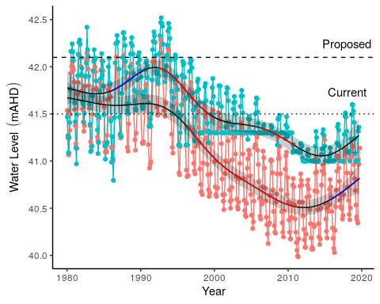

Figure 24 Ground and surface water levels recorded at bore 61610685 (red) and staff gauge 6162577 (blue) that represent changes in water levels at Lake Mariginiup.

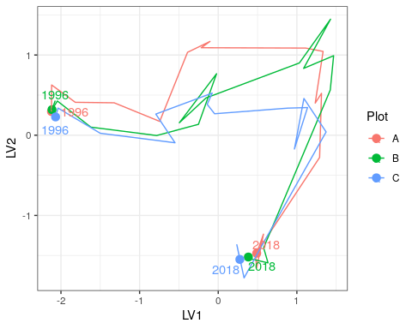

Figure 25 Unconstrained ordination based on the latent variable model for each surveyed year for Lake Mariginiup. Plots are represented as different colours and consecutive years are joined by a line with first and last survey years labeled.

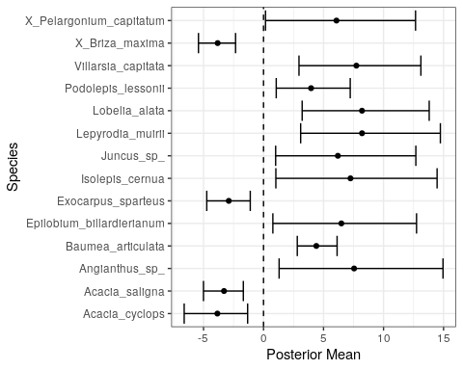

Figure 26 Estimated mean regression coefficients (dots) and 95% credible intervals (bars) for effect of groundwater levels at Lake Mariginiup on vegetation species cover abundances based on Bayesian Regression Analysis (HUI REF 2015). Species with a negative mean posterior value are likely to increase in cover abundance as water levels decline and species with positive values are predicted to increase in cover abundance with increasing water levels. Only those species with coefficients significantly different to zero are shown.

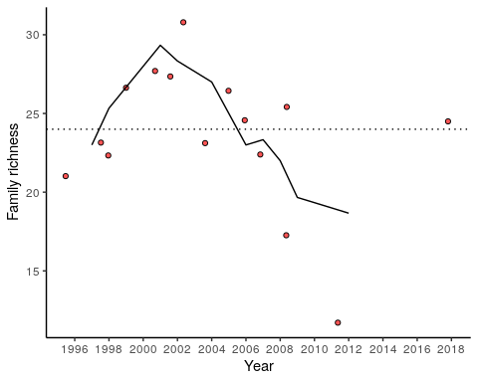

Figure 27 Richness of aquatic invertebrate families for each year at Lake Mariginiup. Line is a moving 3-year average.

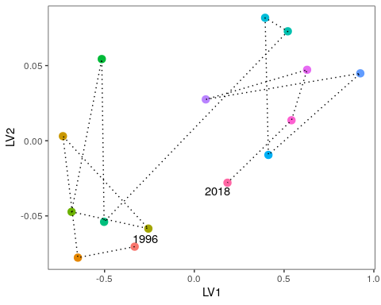

Figure 28 Unconstrained ordination based on invertebrate data for each surveyed year for Lake Mariginiup. Consecutive years are joined by a line with first and last survey years labeled.

## Lake Jandabup

Lake Jandabup is an artificially watered wetland that supports the most diverse sedge and macrophyte vegetation communities in the Bassendean Dune wetlands (Judd and Horwitz, 2019). Lake Jandabup has a high conservation value as it is one of the few ‘eastern circular wetlands’ to not be permanently acidic. Low rainfall and groundwater abstraction impacts are thought to have caused an acidification event in 1998 and 1999 but restoration of water levels by artificial augmentation has returned the pH to normal levels (Judd and Horwitz, 2019). The waters usually have low levels of nutrients and clear waters that supports a diverse aquatic invertebrate community. The current trajectory of the macroinvertebrate community suggests the assemblage is transitioning towards a state that will be like the communities of Lake Mariginiup and Melaleuca Park 173. All these wetlands have waters with pH <7 suggesting acidification is having a significant influence on the composition of these communities. The abundance of invertebrates and fringing vegetation habitats also allow the wetland to support high numbers of resident and visiting water birds (Bamford and Bamford, 2003).

### Hydrology

Surface water levels of Lake Jandabup have only declined slightly since 1980 (Figure 29). Mean maximum seasonal water levels are now 0.2 m lower than in 1994-1999 but mean minimum seasonal water levels are 0.1 m higher than 1994-1999 levels and since 2009, the period of annual maximum to minimum water levels has increased (Table 12). Projected ground water levels in the vicinity of this wetland are predicted to increase by 3.4 m in 2030 due to proposed changes in abstraction and proposed changes to the ministerial criteria suggest adopting the current absolute minimum peak of 44.3 mAHD. It is unlikely surface waters will need to be sustained artificially and that an increased threshold level can be proposed.

Table 12 Five year summaries of surface water level data at Lake Jandabup

|  |  |  |  |  |
| --- | --- | --- | --- | --- |
| Period | Mean max seasonal  level (mAHD) | Mean min seasonal  level (mAHD) | Mean seasonal change (m) | Mean max to min (days) |
| 08/1994 – 07/1999 | 44.9 (Oct) | 44.1 (Feb) | 0.81 | 156 |
| 08/1999 – 07/2004 | 44.9 (Sep) | 44.2 (Mar) | 0.64 | 151 |
| 08/2004 – 07/2009 | 44.8 (Jul) | 44.2 (Mar) | 0.59 | 108 |
| 08/2009 – 07/2014 | 44.7 (Oct) | 44.2 (Jan) | 0.52 | 164 |
| 08/2014 – 07/2019 | 44.7 (Sep) | 44.2 (Mar) | 0.51 | 182 |

### Site summary

Many of the site values of Lake Jandabup are likely to be maintained under the proposed changes to groundwater abstraction (

Table 13). Maintaining surface water levels at the current levels will minimise the risk of further acidification by ensuring sediments remain wet. It is predicted here that many native vegetation species are likely to increase in cover abundance given higher water levels. If water levels raise to the point were artificial augmentation is no longer required, restoration of the hydrological regime may facilitate the expansion of wader habitat as seasonal variation in surface water levels increases towards 0.8 m. The current low pH of the wetland is driving the aquatic macroinvertebrate community away from pre-2000 compositions and towards an composed of a less diverse, acidophile community that is likely to also occur at Lake Mariginiup and Melaleuca Park 173. Careful monitoring of nutrient levels is required also as increased nitrogen levels may also be driving the shift in this aquatic community.

Table 13 Ecological consequences of revised thresholds in terms of compliance of stated site values and site management objectives at Lake Jandabup.

|  |  |  |
| --- | --- | --- |
|  | Likely effect of 2030 revised thresholds | Future Compliance |
| **Site values** |  |  |
| * Most diverse sedge and macrophyte vegetation of all Bassendean dune wetlands, including unusual species | The diverse sedge communities are likely to persist as higher water levels provide additional habitat. WHAT ARE THE UNUSUAL SPECIES??? | Likely |
| * Supports wide range of waterbirds, especially waders | Provided that seasonal variation in water levels is restored, extensive habitat for waders will continue being a feature of this wetland as seasonal high waters prevent macrophyte encroachment of wader habitat during periods of minimum water levels. Seasonal variation in water levels has decreased from about 0.8 m to 0.5 m. Restoration of hydrological regime is likely to restore seasonal variation to pre-2000 levels and extend feeding habitat for waders. | Likely |
| * Extremely good water quality with low nutrients | Water quality has been compromised by reduced buffering capacity that makes the wetland susceptible to acidification. Sediments need to be prevented from drying to prevent further acidification. Nutrient levels are also rising and may be causing shifts in the aquatic invertebrate assemblages. The proposed changes to the threshold levels will minimise the risk of further acidification but elevated nutrient levels will remain a concern. | Unlikely |
| **Site management objectives** |  |  |
| * Conservation of flora and fauna | Native plant species are predicted to increase in abundance if water levels continue to increase. This will have a beneficial effect for other terrestrial fauna that inhabit the wetland. Wader bird habitat is also likely to remain a feature of this wetland. Elevated nutrient levels and low pH are a concern as the aquatic macroinvertebrate community transitions towards a less diverse, acidophilic composition. | Likely for waders and vegetation. Unlikely for aquatic inverts unless pH is restored. |
| * Maintenance of the current extent of wading bird habitat | Greater seasonal variation and higher surface water levels are likely to maintain or expand current feeding habitat for waders. | Very likely |
| * No expansion in the areas of sedge vegetation, but maintenance of existing areas | Modeling does not suggest sedge vegetation is likely to increase although higher water levels are likely to provide additional habitat for fringing vegetation. | Likely |
| * Removal of mosquito fish from the lake | NOT SURE | NOT SURE |
| * Maintenance of high species richness of aquatic macroinvertebrates, macrophytes and sedge vegetation | The proposed changes will maintain the rich macrophytic and sedge vegetation. Acidification is reducing the richness of the aquatic macroinvertebrate community, and unless pH can be restored, this community is likely to continue to transition to an acidophilic community. | Likely for macrophytes and sedges. Unlikely for aquatic macroinvertebrates |

### 

### Water quality

The pH of Lake Jandabup has not exceeded 7.0 since 2011 and is currently between 6.1 and 6.6. Low water levels expose sediments at Lake Jandabup, making it susceptible to acidification. Alkalinity is currently very low, suggesting that the lake may be losing its capacity to buffer pH changes. Deterioration of the chloride:sulphate ratio is also concerning. Maintaining high water levels may be essential to preventing the drying of sediments around the lake margin and subsequent acidification of this wetland. Typically, Lake Jandabup is a low nutrient wetland, however current total nitrogen and phosphorus levels are currently the highest recorded for the monitoring period.

### Vegetation dynamics

The Lake Jandabup wetland consists of a diverse community of native vegetation. In the 2017-2018 season, 43 native species were recorded with only 14% of the total cover abundance belonging to exotic species (Buller et al., 2019). There are four overstorey species present at the wetland, including *Banksia attenuata*, *Banksia ilicifolia*, *Banksia menziesii*, *Eucalyptus rudis* and *Maleleuca preissiana*, all of which have been increasing in health. A dense understory of *A. scoparia*, *B. elegans* and *H. angustifolium* exists at the lower elevated plots A and B. There has been a continual shift in community composition of Lake Jandabup throughout the monitoring period that reflects changes in invasive species cover abundances (Figure 30). A number of species are predicted to increase in cover abundance with increasing water levels, particularly *Euchilopsis linearis* which is currently present in the lower parts of the basin (Figure 31).

### Aquatic invertebrates

Family richness of aquatic macroinvertebrates in Lake Jandabup is distinct and higher than other monitored sites because of the relatively high degree of habitat diversity. However, the family richness of the lake has been below average for the lake since 2016 (Figure 32). There has been a recent shift in community composition away from the 1996 community, suggesting that the community may continue to shift away from what has typically been recorded in the lake in future years as water quality and hydrological changes alter ecosystem processes (Figure 33). The highly variable communities between 1996-2006 may be in response to acidification events. Ceinidae, Calanoida, Daphniidae and Notonectidae are usually present in the lake at high abundance.

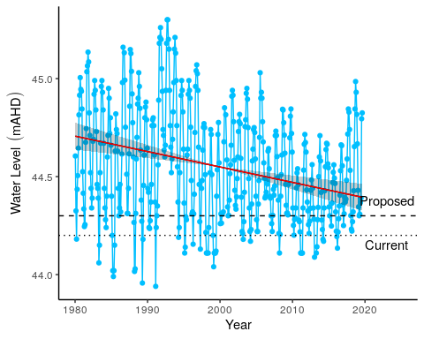

Figure 29 Surface water levels for Lake Jandabup recorded at staff 6162578. Red segments on fitted line represent statistically significant periods of declining water levels and blue segments represent periods of increasing water levels. Dotted line represent current ministerial threshold and dashed line represents the proposed threshold for 2030.

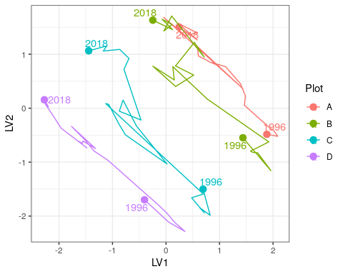

Figure 30 Unconstrained ordination based on the latent variable model for each surveyed year for Lake Jandabup. Plots are represented as different colours and consecutive years are joined by a line with first and last survey years labeled.

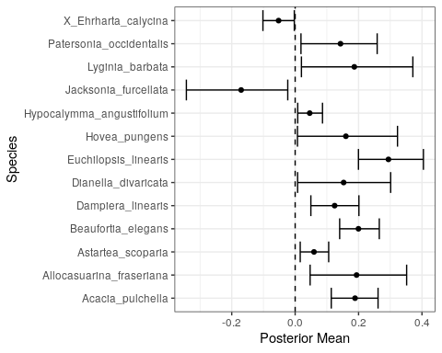

Figure 31 Estimated mean regression coefficients (dots) and 95% credible intervals (bars) for effect of groundwater levels at Lake Jandabup on vegetation species cover abundances based on Bayesian Regression Analysis (HUI REF 2015). Species with a negative mean posterior value are likely to increase in cover abundance as water levels decline while species with positive values are likely to increase in cover abundance as water levels increase. Only those species with coefficients significantly different to zero are shown.

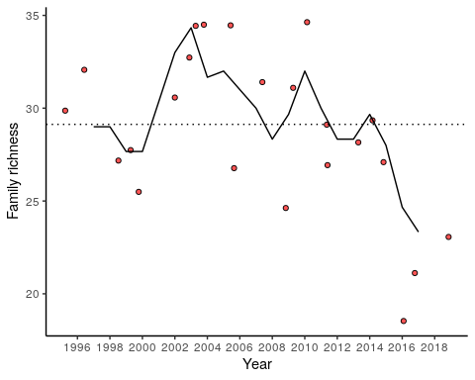

Figure 32 Richness of aquatic invertebrate families for each year at Lake Jandabup. Line is a moving 3-year average.

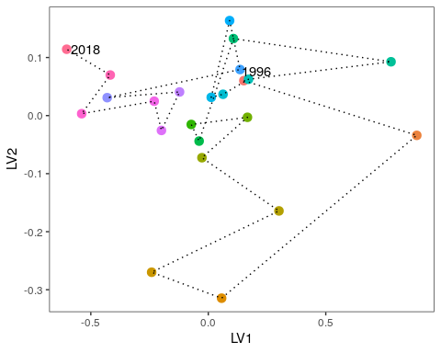

Figure 33 Unconstrained ordination based on invertebrate data for each surveyed year for Lake Jandabup. Consecutive years are joined by a line with first and last survey years labeled.

## Lake Nowergup

Lake Nowergup is one of the deepest permanent lakes on the Swan Coastal Plain and provides a permanent habitat for aquatic invertebrates and fish, as well as an important drought refuge for water birds (R Froend, et al., 2004). Despite the wetlands being artificially maintained since 1989, water levels have continued to decline. This decline has altered the fringing vegetation of the lake and reduced the area of permanent water.

### Hydrology

Since 2010, surface water levels in the lake have decline significantly to levels that are currently below the minimum reading on the staff gauge 6162567 (Figure 34). Groundwater levels at the nearby bore 61611247 have shown similar trends as surface water levels. Between 2008 and 2014, groundwater levels at the bore have declined by more than 1.0 m. A similar decline in surface waters is likely and measurements from this bore have been used in the vegetation analysis. Currently, groundwater levels have increased to above 15 mAHD due to recent rainfall. Mean seasonal maximum groundwater levels from the 1994-1999 period to the 2014-2019 period declined by 1.7 m, while for the mean minimum water levels the decline was 1.5 m (Table 14). Maximum and minimum water levels now tend to occur earlier in the year than previously. Proposed threshold levels will apply to bore 61610601, where under proposed reduction in abstraction a threshold at 18.0 mAHD should be achievable. This is likely to correspond to threshold level of 16.0 mAHD at the staff gauge, 0.8 m lower than the current threshold.

Table 14 Five year summaries of surface water level data at Lake Nowergup

|  |  |  |  |  |
| --- | --- | --- | --- | --- |
| Period | Mean max seasonal  level (mAHD) | Mean min seasonal  level (mAHD) | Mean seasonal change (m) | Mean max to min (days) |
| 08/1994 – 07/1999 | 16.6 (Oct) | 15.3 (May) | 1.30 | 144 |
| 08/1999 – 07/2004 | 16.5 (Oct) | 14.8 (May) | 1.69 | 53 |
| 08/2004 – 07/2009 | 16.6 (Oct) | 15.6 (Jan) | 1.02 | 14 |
| 08/2009 – 07/2014 | 15.6 (Sep) | 13.4 (Mar) | 2.11 | 222 |
| 08/2014 – 07/2019 | 14.9 (Jul) | 13.8 (Apr) | 1.07 | 19 |

### Site summary

Many of the site values of Lake Nowergup are unlikely to be maintained under the proposed changes to groundwater abstraction (

Table 15). Declining water levels have, and will continue to, cause a significant decline in macroinvertebrate richness and shift in assemblage composition away from what was once typical of this wetland. This deterioration of the macroinvertebrate community is probably driven by a decline in habitat availability for these organisms, although increased nutrient levels may also be facilitating this process. Although many native vegetation species are predicted to increase in cover abundance with declining water levels, there is a substantial decline in fringing wetland vegetation an sedges. This continued terrestrialisation of the vegetation community will further impact the macroinvertebrate communities as many of these species (e.g. *B. articulata*) provide important habitat for many macroinvertebrate species and reduce the effect of nutrient enrichment.

Table 15 Ecological consequences of revised thresholds in terms of compliance of stated site values and site management objectives at Lake Nowergup.

|  |  |  |
| --- | --- | --- |
|  | Likely effect of 2030 revised thresholds | Future Compliance |
| **Site values** |  |  |
| * As a permanent deep-water wetland acts as a major drought refuge for waterbirds | REALLY DEPENDS ON HOW SHALLOW THE LAKE WILL BECOME. ANY INFORMATION? | UNKNOWN |
| * Supports dependent invertebrates and fish species (one native, Swan River Goby (*Pseudogobius olorum*); and one exotic, Mosquito fish (*Gambusia holbrooki*) | Dependent on extent of reduced water area and depth COMMENTS? | UNKNOWN |
| * Large areas of sedges minimize impact of nutrient enrichment on aquatic fauna | Likely to be jeopardised with declining water levels. Modelling predicts a decline in *B. articulata* and *T. orientalis* as water levels recede further. | Very unlikely |
| **Site management objectives** |  |  |
| * Wildlife and conservation, scientific study and preservation of features of archaeological, historic or scientific interest | NOT SURE? | COMMENTS? |
| * Maintain the existing areas of fringing sedge vegetation | Existing areas of sedge vegetation are likely to become terrestrialised. Sedges will be required to migrate down-slope with receding surface water levels and are likely to be reduced in extent. | Very unlikely |
| * Maintain deep, permanent water as a bird habitat and drought refuge and to protect aquatic invertebrates and fish dependent on permanent water | The decline of surface water levels will reduce the areas of deep water and jeopardise the habitat available to birds and fish. The function of the lake as a drought refuge for birds will diminish. | At a reduced capacity |
| * Maintain the existing extent of *Baumea* fringe between *Typha* stands and the fringing woodland | Modelling predicts *B. articulata* and *T. orientalis* to decline further. Existing stands are likely to disappear and will need to establish down-slope. The extent of these stands will decrease. | Very unlikely |
| * Provide some area of wading bird habitat at the end of summer, although it is recognized that this is limited by the shape of the wetland. | UNKNOWN Depends on seasonal variation allowing areas of mudflats suitable for waders to establish. IS THIS LIKELY? | UNKNOWN |

### 

### Water quality

Water quality in Lake Nowergup is remarkably stable given the declines in surface waters and associated groundwaters (Judd and Horwitz, 2019). Acidity is usually low and alkalinity high, indicating that the lake has sufficient capacity to buffer against acidification. A pH above 9 is not unusual for this system. Recent monitoring suggests the lake currently has high nutrient levels, with current total nitrogen and total phosphorus at record high concentrations for the lake, and among the highest for all Spearwood Dune wetlands. Current nitrogen levels are twice the long-term mean levels. Livestock has recently been able to access the lakebed and may be the cause of elevated nutrients.

### Vegetation Dynamics

There are two vegetation monitoring transects at Lake Nowergup, one in the northern part of the lake and one in the southern part. Both transects were established in 1996 and the northern one was last surveyed in 2016 while the southern one was last surveyed in 2018. In 2001, the original plots were realigned to better encompass wetland vegetation near the lake. Therefore, only post 2001 data is analysed here. In both transects, there has been a recent shift in vegetation composition of the down-slope plots (A and B) transitioning towards the higher, more terrestrial plots (C and D; Figure 35). This shift has been driven by declines of *B. articulata* and *M. rhaphiophyla* and the increase of *E. rudis*. Further declines in water level are likely to decrease the abundance of fringing vegetation *B. articulata* and *Typha orientalis*. Other native species, including *E. rudis*, *Lepidosperma longitudinale* and *Rhagodia baccata* are likely to increase in abundance (Figure 36), particularly at lower elevations of the basin.

### Macroinvertebrates Dynamic

Aquatic invertebrate richness has been below average for Lake Nowergup since 2010, with 19 families detected for the last three sampling occasions (Figure 37). There is currently a trend of declining richness since 2008. This decline in richness is likely due to the loss of fringing macrophytes due to declining water levels and submerged macrophytes in the center of the lake which have also disappeared (GMEMP 2018). Loss of macrophytic habitat has coincided with elevated nutrient levels which would have also altered ecological processes and invertebrate assemblages. Ordination reveals a marked change in assemblage composition from 1996 to 2018 (Figure 38). Communities appeared to be shifted most dramatically from 2002 to 2006 which coincides with supplementation of surface waters by artificial watering. The current shift away from the 1996 community may be driven by the high nutrients being experienced at the lake. Changes can be associated to loss of Ceinidae, Amphisopidae, Notodromadidae and Chydoridae. As stated by Judd (2019) “*The macroinvertebrate monitoring undertaken in 2018 confirms the trends of reduced richness and changing assemblages. The artificial maintenance regime at this wetland was clearly inadequate to maintain ecological integrity and has failed to prevent a loss of habitats, the consequence of lowered water levels. The resulting change in invertebrate assemblages may well be irreversible and steps to restore more representative assemblages must involve more than maintenance of minimum water levels.*”

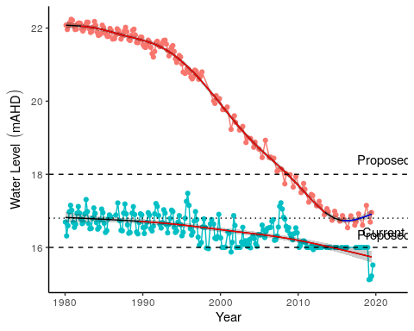

Figure 34 Ground and surface water levels for Lake Nowergup recorded at bore 61610601 (red) and staff gauge 6162567 (blue). The minimum recordable water level for the staff gauge is 16.0 mAHD. Blue dots at 16.0 mAHD represent water levels below the minimum level measurable at the staff gauge. Red segments on fitted line represent statistically significant periods of declining water levels and blue segments represent periods of increasing water levels.

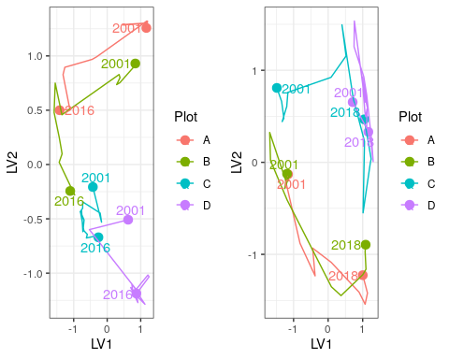

Figure 35 Unconstrained ordination based on the latent variable model for each surveyed year for the northern (left) and southern (right) Lake Nowergup transects. Plots are represented as different colours and consecutive years are joined by a line with first and last survey years labeled.

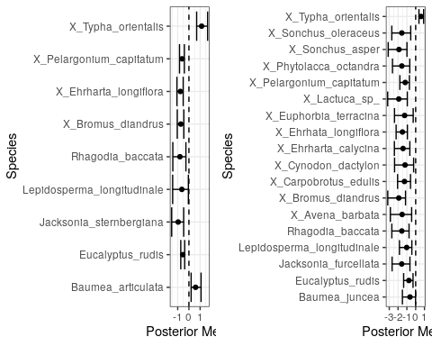

Figure 36 Estimated mean regression coefficients (dots) and 95% credible intervals (bars) for effect of groundwater levels at the northern (left) and southern (right) Lake Nowergup transects on vegetation species cover abundances based on Bayesian Regression Analysis (HUI REF 2015). Species with a negative mean posterior value are likely to increase in cover abundance as water levels decline and species with positive values are likely to increase in cover abundance when water levels increase. Only those species with coefficients significantly different to zero are shown.

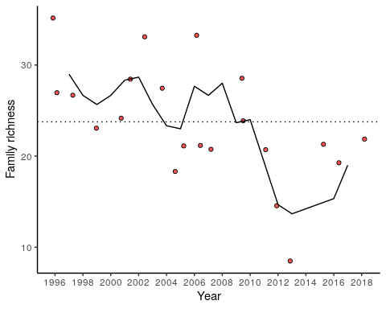

Figure 37 Richness of aquatic invertebrate families for each year at Lake Nowergup. Line is a moving 3-year average.

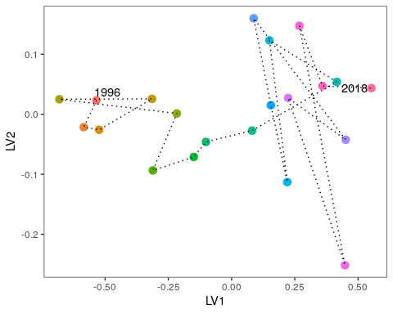

Figure 38 Unconstrained ordination based on invertebrate data for each surveyed year for Lake Nowergup. Consecutive years are joined by a line with first and last survey years labeled.

## Lake Wilgarup

Lake Wilgarup is a high conservation, seasonally inundated Dampland located in the southern area of Yanchep National Park. The basin covers an area of 16 ha in a limestone depression that experiences discharge from rising groundwaters. There are extensive peat deposits in the lakebed that suggest the sediments have been saturated for a long period. Surface waters have not been recorded in the basin since 1998 and peats are now dry and vulnerable to combustion.

### Hydrology

Groundwater levels have been recorded at the nearby bore 61618500 since 1997 (Figure 39). There has been a significant decline in groundwater levels throughout this monitoring period from 4.75 to 3.25 mAHD despite recent increased annual rainfall. Maximum and minimum seasonal groundwater levels have decreased by 1.6 and 1.2 m, respectively (Table 16). Maximum water levels have consistently occurred during September-October, but minimum water levels are now occurring later in the year with the site experiencing a longer period of drying. The wetland has been non-compliant with ministerial thresholds for most of the monitoring period. A proposed threshold at 0.5 m lower than the current threshold is likely to be achievable under proposed reductions in abstraction by 2030. These changes in abstraction may result in small increases in groundwater levels but are likely to reduce the risk of further declines.

Table 16 Five year summaries of ground water level data at Lake Wilgarup

|  |  |  |  |  |
| --- | --- | --- | --- | --- |
| Period | Mean max seasonal  level (mAHD) | Mean min seasonal  level (mAHD) | Mean seasonal change (m) | Mean max to min (days) |
| 08/1994 – 07/1999 | 5.2 (Oct) | 4.3 (Sep) | 0.91 | 184 |
| 08/1999 – 07/2004 | 4.7 (Oct) | 4.0 (Feb) | 0.73 | 193 |
| 08/2004 – 07/2009 | 4.3 (Sep) | 3.7 (Apr) | 0.62 | 150 |
| 08/2009 – 07/2014 | 3.8 (Oct) | 3.2 (Apr) | 0.59 | 190 |
| 08/2014 – 07/2019 | 3.6 (Oct) | 3.1 (Mar) | 0.55 | 212 |

### Site summary

The site values of Lake Wilgarup are unlikely to be maintained under the proposed changes to groundwater abstraction (

Table 17). Vegetation composition has shifted from one dominated by wetland species, such as *B. articulata*, to a terrestrial community dominated by *E. gomphocephala*. Increases in groundwater are unlikely to have an impact on the vegetation unless permanent water can be restored.

Table 17 Ecological consequences of revised thresholds in terms of compliance of stated site values and site management objectives at Lake Wilgarup.

|  |  |  |
| --- | --- | --- |
|  | Likely effect of 2030 revised thresholds | Future Compliance |
| **Site values** |  |  |
| * One of few remaining undisturbed wetlands within the region | Declining groundwater and fire render this wetland highly disturbed. The vegetation composition no longer reflects that of a wetland as the site has become highly terrestrialised. | Extremely unlikely |
| * Rich and unusual vegetation (dense monospecific stands of sedges) | These sedges are locally extinct. | Extremely unlikely |
| * Likely to support diverse fauna | A rich woodland fauna likely exists at the site; however, this assemblage would not reflect the rich wetland fauna that would have once occupied the site. | Extremely unlikely |
| **Site management objectives** |  |  |
| * Maintain the environmental quality of Lake Wilgarup | The quality of Lake Wilgarup as a Swan Coastal Plain wetland has been permanently compromised. As it is extremely unlikely that permanent water will become a feature of Lake Wilgarup in the future, the site will not retain its environmental quality. | Extremely unlikely |
| * Maintain the existing extent and variety of wetland vegetation | Wetland vegetation has probably been permanently destroyed by declining water levels and fire. The terrestrial woodlands that now inhabit the site are unlikely to facilitate the return of wetland vegetation unless permanent water is restored to the site. | Extremely unlikely |

### 

### Vegetation dynamics

A vegetation monitoring transect was established at Lake Wilgarup in 1997 and was last surveyed in 2012. Two additional sites were added to the transect in 2009 down-slope of Plot A. The sedges, *Baumea articulata*, *Baumea juncea* and *Baumea vaginalis* have all disappeared from the wetland during the monitoring period. Tuart trees (*Eucalyptus gomphocephala*) have migrated down slope during the monitoring period and were recorded in Plot A in 2005. Plots A, B and C display similar shifts in community composition during the monitoring period, while Plot D displayed a significant change in composition in 2004-2005 in response to fire (Figure 40). Under a scenario of continuing groundwater decline, regression analysis reveals that a number of exotic species, including *Ehrharta longiflora* and *Bromus diandrus*, are likely to increase in cover abundances (Figure 41).

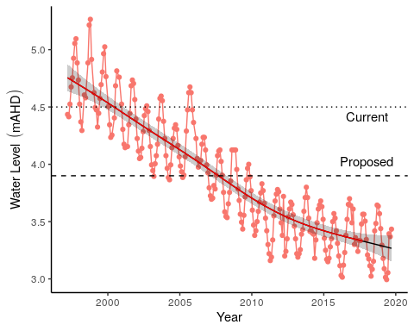

Figure 39 Groundwater levels recorded at bore 61618500 in the vicinity of Lake Wilgarup. Red segments along trendline indicate periods of significant decline in groundwater levels.

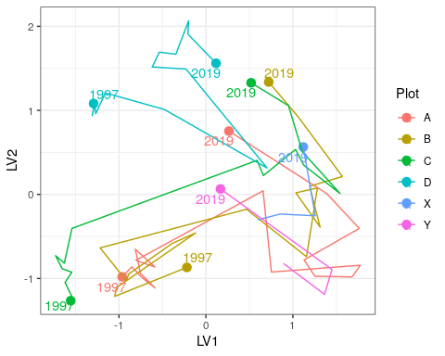

Figure 40 Unconstrained ordination based on the latent variable model for each surveyed year for Lake Wilgarup. Plots are represented as different colours and consecutive years are joined by a line with first and last survey years labeled.

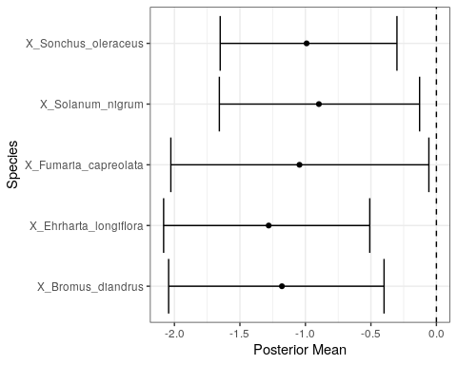

Figure 41 Estimated mean regression coefficients (dots) and 95% credible intervals (bars) for effect of groundwater levels at Lake Wilgarup on vegetation species cover abundances based on Bayesian Regression Analysis (HUI REF 2015). Species with a negative mean posterior value are likely to increase in cover abundance as water levels decline. Only those species with coefficients significantly different to zero are shown.

## Pipidinny Swamp

Vegetation damaged by a fire in 2005. Macroinvertebrate and water quality monitoring occurred in the 2000s but ceased in 2011 as the wetland was atypical and had little water. A single vegetation survey has been conducted in September 2019 and the results presented here.

### Hydrology

There has been at least a 2 m decline in surface water levels at Pipidinny Swamp since the mid 1990’s, although measurements at the staff gauge were frequently below the minimum recordable level in the mid-late 2000’s to 2019 despite the gauge being moved in 2010 (Figure 42). Mean maximum seasonal surface waters are at least 1.2 m lower now than in the 1994-1999 seasons (Table 18). Records of minimum levels are difficult to interpret due to the water levels frequently being below the staff gauge. Groundwater levels at the nearby bore 61611872 suggest that water levels at the swamp are no longer in decline, however this conclusion assumes groundwater levels at the bore and surface water levels at the staff gauge are related. It is not possible to verify this assumption as groundwater measurements have only been made while the surface water levels have been below detection limits for the staff gauge.

It is likely that water levels in Yanchep National Park will increase under the proposed 2030 changes in groundwater abstraction. The proposed threshold level of 1.1 m at bore 61611872 is likely to slightly increase or stabilise surface water levels in Pipidinny Swamp.

Table 18 Five year summaries of surface water level data at Pipdinny Swamp

|  |  |  |  |  |
| --- | --- | --- | --- | --- |
| Period | Mean max seasonal  level (mAHD) | Mean min seasonal  level (mAHD) | Mean seasonal change (m) | Mean max to min (days) |
| 08/1994 – 07/1999 | 3.2 (Sep) | 1.8 (May) | 1.34 | 213 |
| 08/1999 – 07/2004 | 2.8 (Oct) | 1.8 (Mar) | 0.98 | 168 |
| 08/2004 – 07/2009 | 2.4 (Sep) | 2.0 (Nov) | 0.39 | 12 |
| 08/2009 – 07/2014 | 2.0 (Oct) | 1.0 (Jul) | 0.98 | 88 |
| 08/2014 – 07/2019 | 2.0 (Sep) | 1.0 (Jan) | 0.97 | 124 |

### Site summary

The proposed reductions to abstraction are not likely to restore surface water levels to pre-2000 levels at Pipidinny Swamp which will affect the capacity maintaining the site values (

Table 19). Features that characterised this wetland before the significant decline in water levels are unlikely to return given the predicted outcomes of reduce abstraction as water levels will be maintained at levels much lower than was once typical of the wetland. However, the water levels are predicted to be slightly higher than current levels, which will have a beneficial effect on fringing vegetation health. Given the location of this swamp in an increasingly urbanised region and the altered hydrological regime, it is likely that exotic vegetation species will remain a feature of this swamp.

Table 19 Ecological consequences of revised thresholds in terms of compliance of stated site management objectives at Pipidinny Swamp.

|  |  |  |
| --- | --- | --- |
|  | Likely effect of 2030 revised thresholds | Future Compliance |
| **Site management objectives** |  |  |
| * Improve groundwater levels to increase area of permanent deep water habitat for fauna | Water levels are currently more than 1 m lower than pre-2000 levels. Proposed changes to abstraction are unlikely to restore the swamp to pre-2000 levels but are likely to maintain slightly higher levels than currently exist. The slightly deeper waters will provide additional habitat for aquatic fauna than currently exists. | Possible |
| * Improve groundwater levels to maintain fringing vegetation to support a range of habitat types for macroinvertebrates | Fringing vegetation is likely to persist with higher surface water levels, although this prediction is not based on empirical data. If fringing *B. articulata* and *T. orientalis* continue to occur, additional habitat for aquatic macroinvertebrates may become available. | Possible |

### 

### Vegetation dynamics

The transect at Pipidinny Swamp consists of a series of depressions/swamps interspersed with tracks and grassy banks. The transect was established close to the bore but was only 20 m in length due to the terrain. Subsequently, only four *Melaleuca* trees could be included. Species richness and diversity on and around the transect was low, with *Acacia saligna* the dominant overstorey species, although *Melaleuca rhaphiophylla* appeared in good health (both on and around the transect). *Baumea articulata* was present, albeit in low abundance, several meters up slope from the surface water, and was in moderate health with a couple of dead stems present. No recruitment was recorded. The location’s potential value as important habitat was indicated by the presence of a south west carpet python (*Morelia apilota*) in amongst the *Typha orientalis* during the 2019 survey. Several exotic species are abundant at the site, including *Bromus diandrus*, *Ehrharta longiflora* and the potentially invasive native bullrush *T. orientalis*.

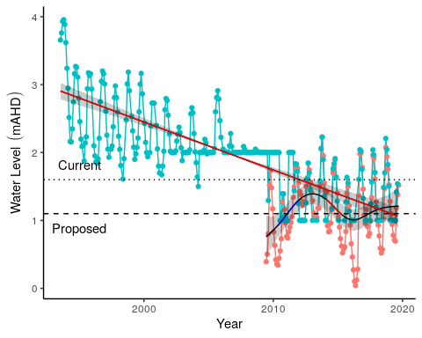

Figure 42 Ground and surface water levels recorded at bore 61611872 (red) and staff gauge 6162624 (blue) that represent fluctuations in water levels at Pipidinny Swamp. Surface water levels were initially only recordable above 2 mAHD and later above 1 mAHD. Red segments of trend line represent periods of significant decline in water levels while blue segments represent periods of significant increases in water levels.

Table 20 Vegetation cover abundance at the two plots established at Pipidinny Swamp in September 2019.

|  |  |  |  |
| --- | --- | --- | --- |
| Species | Plot A | Plot B | Status |
| *Bromus diandrus* | 4 | 9 | Exotic |
| *Cirsium vulgare* | 2 | 0 | Exotic |
| *Ehrharta longiflora* | 7 | 9 | Exotic |
| *Euphorbia sp.* | 0 | 1 | Exotic |
| *Fumaria muralis* | 2 | 3 | Exotic |
| *Pelargonium capitatum* | 2 | 2 | Exotic |
| *Sonchus oleraceus* | 2 | 1 | Exotic |
| *Symphiotrichum squamatum* | 1 | 0 | Exotic |
| *Acacia saligna* | 6 | 10 | Native |
| *Baumea articulata* | 2 | 0 | Native |
| *Melaleuca rhaphiophylla* | 4 | 0 | Native |
| *Myoporum caprarioides* | 3 | 2 | Native |
| *Rhagodia baccata* | 3 | 4 | Native |
| *Spyridium globulosum* | 3 | 3 | Native |
| *Typha orientalis* | 6 | 0 | Native |

## Lexia 186

The Lexia 186 wetland has a high conservation value because it consists of a largely undisturbed Sumpland habitat with a diverse vegetation community that provides significant habitat for fauna (R Froend, et al., 2004). The Lexia system of wetlands is composed of three separate wetlands, Lexia 86, Lexia 94 and Lexia 186. Lexia 186 was normally a seasonally waterlogged basin (Dampland), however, prolonged decline of groundwater levels mean water levels are now below the level of the basin all year. There have been dramatic shifts in fringing vegetation health and composition as the basin sediments dry and oxidise.

### Hydrology

There has almost been a significant decline in groundwater levels at Lexia 186 from 1996 to 2015 by approximately 1 m and a significant increases in water levels since 2015 by 0.5 m (Figure 43). Nonetheless, current mean maximum and minimum water levels are 1.2 and 0.8 m below 1994-1999 levels and seasonally minimums are occurring earlier in the year (Table 21). Groundwater levels at Lexia 186 have been non-compliant since 2000. Proposed reductions in groundwater abstraction are not projected to increase water levels in the Dampland, therefore a threshold 0.7 m below the current threshold has been proposed for 2030. This projection will maintain groundwater at similar levels to the period between 2010-2015.

Table 21 Five year summaries of surface water level data at Lexia 186

|  |  |  |  |  |
| --- | --- | --- | --- | --- |
| Period | Mean max seasonal  level (mAHD) | Mean min seasonal  level (mAHD) | Mean seasonal change (m) | Mean max to min (days) |
| 08/1994 – 07/1999 | 3.2 (Sep) | 1.8 (May) | 1.34 | 213 |
| 08/1999 – 07/2004 | 2.8 (Oct) | 1.8 (Mar) | 0.98 | 168 |
| 08/2004 – 07/2009 | 2.4 (Sep) | 2.0 (Nov) | 0.39 | 12 |
| 08/2009 – 07/2014 | 2.0 (Oct) | 1.0 (Jul) | 0.98 | 88 |
| 08/2014 – 07/2019 | 2.0 (Sep) | 1.0 (Jan) | 0.97 | 124 |

### Site summary

The site values of the Lexia 186 wetland are unlikely to be maintained under the proposed changes to groundwater abstraction (

Table 22). There has been a significant shift from a seasonally waterlogged basin to a system that is now permanently dry. The proposed reductions in abstraction are not going to restore this important characteristic of the wetland. Instead, predicted changes in water level suggest maintenance of conditions similar to what the site has experienced since 2011. It is likely that vegetation will undergo further shifts in composition, although it is not clear that these shifts are attributed to declining groundwater levels or other processes. Nonetheless, further monitoring will provide additional information as to whether the vegetation is likely to continue to change further.

Table 22 Ecological consequences of revised thresholds in terms of compliance of stated site management objectives at the Lexia 186 wetland.

|  |  |  |
| --- | --- | --- |
|  | Likely effect of 2030 revised thresholds | Future Compliance |
| **Site values** |  |  |
| * Undisturbed by typical impacts | Extensive native vegetation remains a feature of this site despite the significant shifts in composition during the monitoring period. Modelling suggests these shifts are not attributed to changes in groundwater levels. | Likely |
| * Supports diverse vegetation | The proposed thresholds are likely to maintain the high richness of native vegetation of the site, although it is markedly different to 1997 baseline conditions. | Very likely |
| * Significant fauna habitat | The continued diverse native vegetation will continue to provide a rich habitat for fauna. | Very likely |
| **Site management objectives** |  |  |
| * Conserve ecological values | Despite the altered hydrological regime, the site has maintained may of the ecological values that make this site important. These values are likely to persist given the proposed changes to the threshold levels. Nonetheless, the site has been fundamentally altered as it is no longer a seasonally waterlogged Dampland and altered sediment processes are likely contributing to the shift in vegetation community being observed. | Possible |
| * Protect vegetation assemblages in and fringing the wetland | WHAT FRINGING VEGETATION? | ??? |
| * Protect invertebrate communities dependent on the wetland | Given the likely persistence of native vegetation at the site, terrestrial invertebrates will continue to inhabit the site, although this prediction is not based on any empirical evidence. Invertebrates typical of Damplands are likely to have been affected by the declining ground water levels. | UNKNOWN |

### 

### Vegetation dynamics

Vegetation monitoring has been occurring at Lexia 186 since 1997 with the last survey conducted in 2018. Overall canopy health has remained stable with most *Melaleuca preissiana* in good or excellent condition and most *Banksia ilicifolia* with average condition (Buller et al., 2018). Exotic richness is very low at Lexia 186 and natives account for approximately 90 % of total cover abundance at the transect. Ordination reveals similar trajectories in compositional change for each plot that reflect the continual changes in cover abundances of species (Figure 44). Regression analyses did not reveal significant effects of groundwater levels on any of the species present at Lexia 186. This result suggests that community composition is changing due to other factors that are independent of groundwater level. This is surprising given the significant declines in groundwater at the site. Vegetation may be altered by other processes such as altered sediment processes and acidification.

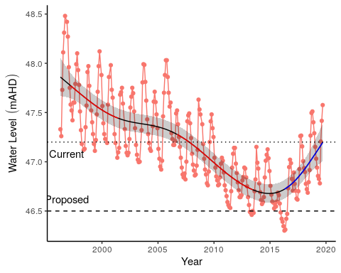

Figure 43 Groundwater levels recorded at bore 61613214 that represent water level fluctuations at Lexia 186. Red segments represent periods of significant decline in water levels while blue segments represent periods of significant increase in water levels.

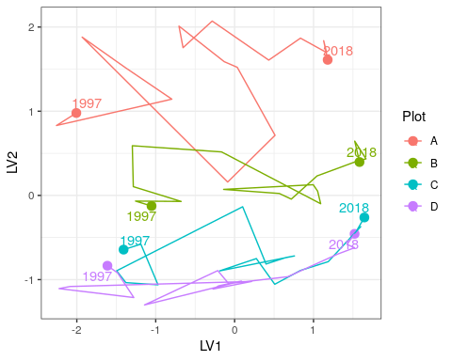

Figure 44 Unconstrained ordination based on the latent variable model for each surveyed year for Lexia 186. Plots are represented as different colours and consecutive years are joined by a line with first and last survey years labeled.

## Melaleuca Park 173

Melaleuca Park 173 (EPP 173) is located within the Bassendean North Vegetation Complex and represents a regionally significant wetland (Hill et al., 1996). Normally, the site represents a permanently filled lake that is fed from a series of springs along the western margin of the basin (R Froend, et al., 2004; Judd and Horwitz, 2019). The waters supported a rich macroinvertebrate community and an endemic population of the black-striped minnow (*Galaxiella nigrostriata*). There have been dramatic decreases in surface and groundwater levels in recent decades, to the point where the lake is almost dry during the summer months. Declining water levels are thought to have caused the local extinction of the black-striped minnow and degradation of fringing vegetation.

### Hydrology and water quality

There has been a prolonged decline in surface water levels since 1990 that show similar trends with fluctuations in groundwater levels (bore 61613213; Figure 45). Surface water level measurements are now unreliable at staff 6162628 due to water levels usually being below the minimum level of the staff. Since 2011, groundwater levels have been stable. Mean maximum and minimum water levels have decreased by 0.8 m and 0.5 m, respectively, since 1994 (Table 23). The latest 5 year period (2014-2019) suggests that groundwaters are reaching annual minimums earlier in the year than in previous seasons. Groundwater levels have been non-compliant during the monitoring period. The proposed threshold level of 48.5 mAHD is 1.7 m lower than the current threshold. Managing the wetland to these levels may result in further declines in water levels.

Table 23 Five year summaries of surface water level data at Melaleuca Park 173. Data is based on data from bore 61613213 as many readings for the surface water staff 6162628 are below the minimum reading of 50.4 mAHD.

|  |  |  |  |  |
| --- | --- | --- | --- | --- |
| Period | Mean max seasonal  level (mAHD) | Mean min seasonal  level (mAHD) | Mean seasonal change (m) | Mean max to min (days) |
| 08/1994 – 07/1999 | 50.9 (Sep) | 49.2 (May) | 1.73 | 242 |
| 08/1999 – 07/2004 | 50.8 (Sep) | 49.1 (May) | 1.66 | 220 |
| 08/2004 – 07/2009 | 50.6 (Sep) | 49.0 (May) | 1.59 | 168 |
| 08/2009 – 07/2014 | 50.0 (Oct) | 48.7 (Jun) | 1.27 | 224 |
| 08/2014 – 07/2019 | 50.1 (Sep) | 48.7 (Apr) | 1.38 | 225 |

### Site summary

It is unlikely that management many of the site values of the Melaleuca Park 173 wetland will be achievable given the projected decline in groundwater levels and loss of permanent water (

Table 24). The vegetation modeling presented here suggests that vegetation from higher elevations of the basin are likely to migrate down-slope as water levels continue to decline. The macroinvertebrate assemblage at Melaleuca Park 173 is displaying similar shifts as the other wetlands that have low pH, such as Lake Jandabup and Lake Mariginiup, which is largely being driven by declining richness.

Table 24 Ecological consequences of revised thresholds in terms of compliance of stated site management objectives at the Melaleuca Park 172 wetland.

|  |  |  |
| --- | --- | --- |
|  | Likely effect of 2030 revised thresholds | Future Compliance |
| **Site values** |  |  |
| * Unique hydrology | Permanent water is no longer a feature of this wetland. The proposed threshold of 48.5 m will continue the transformation of the site into a seasonally inundated wetland | Very unlikely |
| * High vertebrate and macro invertebrate species richness | Aquatic vertebrate and invertebrate richness has declined significantly. Native fish species are probably no longer at the wetland and macroinvertebrate surveys show a clear decline in richness of taxa. Proposed water level changes are not sufficient to reverse this trend. | Very unlikely |
| * Contains most northern population of black stripe minnow (*Galaxiella nigrostriata*) | Probably locally extinct from the wetland due to loss of permanent water. | Very unlikely |
| **Site management objectives** |  |  |
| * Maintain wildlife and landscape values of the wetlands | The functioning of this wetland has changed markedly from a permanently inundated wetland to a seasonally inundated Dampland. This has had a significant effect on the flora and fauna of the site. Nonetheless, the high native vegetation richness of the site is likely to persist and provided habitat for wildlife. | Likely |
| * Maintain the existing areas of wetland and stream vegetation they support | Permanent water is unlikely to become a feature of this wetland under the revised abstraction plan. Seasonal inundation is likely to continue and will maintain many of the components of existing wetland vegetation. | Likely |
| * To protect invertebrate communities dependent on the wetland and stream | Declining waters are attributed to the marked decline in aquatic macroinvertebrate richness. The proposed changes to abstraction are unlikely to reverse this trend. | Unlikely |
| * To protect the fish species, *Galaxiella nigrostriata* | The proposed abstraction plan suggests the wetland will not become permanently inundated, a necessity for fish. Because surface waters will continue to disappear seasonally, the wetland will not provide the habitat required for any fish species. *G. nigrostriata* is likely to be locally extinct from this wetland. | Extremely unlikely |

### 

### Water quality

Melaleuca Park 173 is the only monitored wetland to show organic acidity (Judd and Horwitz, 2019). The waters are dark and have high gilvin levels (94.7 FTU). The acidic waters have a pH between 3.4 and 5.1 and recent monitoring suggests the current pH is 3.7. The lake usually has total nitrogen levels between 2000 and 2800 $μ$ g/L.

### Vegetation dynamics

Vegetation monitoring has been occurring at Melaleuca Park from 1997 to 2018 (Buller et al., 2019). There has been marked changes in vegetation composition along the transect during this monitoring period. In 2014, *Baumea articulata* was absent from the transect, however, due to a wet season which saw Plot A and B submerged in 2018, *B. articulata* was recorded in low abundance. Similar changes have been observed for *Astartea scoparia*, which prior to 2018 was recorded wither dead or in poor condition. Since 2018, many of the *A. scoparia* plants were observed with new shoots. Other important vegetation components in Plot A include *Lepidosperma longitudinale* and *Leptocarpus scariosus*, both of which are also present in Plot B, whilst the former is present throughout the transect. The long-term decline in water levels has had an adverse effect on the health of the *Melaleuca preissiana* population. Generally, this important canopy forming species has been declining in health, despite slight increases in plant health for 2018. The slight increase in *M. preissiana* health may be attributed to the recent stabilisation of groundwater in levels.

Ordination reveals distinct shifts in community composition since 1997 (Figure 46). Although Plot A is distinct, in terms of vegetation cover abundances, to Plots B, C and D, all plots display an upwards trajectory along the second axis (LV2). For Plot A, this the shift in composition is likely due to the loss of *B. articulata* from the plot. Modeling compositional changes in vegetation with changes in groundwater levels suggests a number of species which are likely to increase in cover abundance with declining groundwater levels (Figure 47). These species, such as *Xanthorrhoea preissii* and *Dielsia stenostachya*, are likely to increase in cover abundance in lower areas of the basin under a scenario of continuing declining groundwater levels.

### Aquatic Invertebrates

Aquatic macroinvertebrate family richness has been declining since the late 2000’s when water levels began declining (Figure 48). As water chemistry has changed little during this period, the decline in richness is likely due to the degradation of habitats caused by the lower surface waters and extended dry periods during summer (Judd and Horwitz, 2019). Macroinvertebrate assemblage composition has shifted since the initial 2000 survey (Figure 49). Since 2011, assemblage composition has been shifting away from the 2000 community, suggesting further shifts in composition are likely due to sustained low water levels. Taxa that have disappeared from the wetland include Chydoridae, Leptoceridae, Orthocladiinae and Unioncolidae.

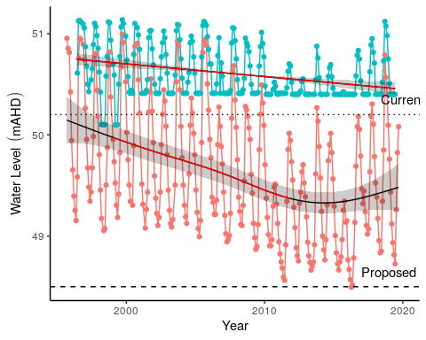

Figure 45 Ground and surface water levels for Melaleuca Park 173 recorded at bore 61613213 (red) and staff 6162628 (blue). The minimum recordable water level for the staff gauge is 50.4 mAHD. Blue dots at 50.4 mAHD represent water levels below the minimum level measurable by the staff. Red segments on fitted line represent statistically significant periods of declining water levels. Current and proposed threshold levels for bore 61613213 are represented by dotted and dashed lines, respectively.

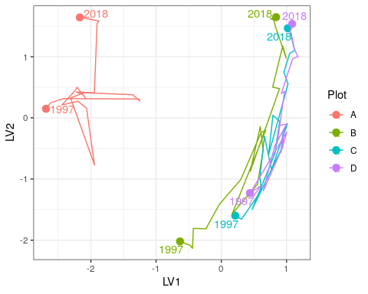

Figure 46 Unconstrained ordination based on the latent variable model for each surveyed year for Melaleuca Park 173. Plots are represented as different colours and consecutive years are joined by a line with first and last survey years labeled.

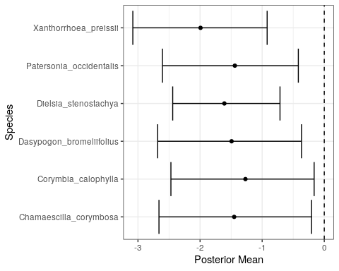

Figure 47 Estimated mean regression coefficients (dots) and 95% credible intervals (bars) for effect of groundwater levels at Melaleuca Park 173 on vegetation species cover abundances based on Bayesian Regression Analysis (HUI REF 2015). Species with a negative mean posterior value are likely to increase in cover abundance as water levels decline. Only those species with coefficients significantly different to zero are shown.

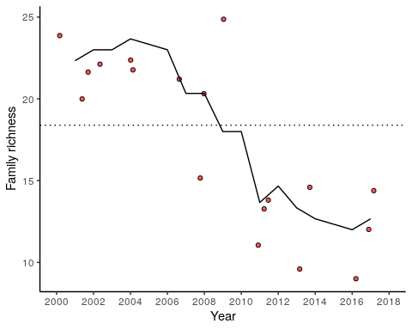

Figure 48 Richness of aquatic invertebrate families for each year at Lake Melaleuca Park 173. Line is a moving 3-year average.

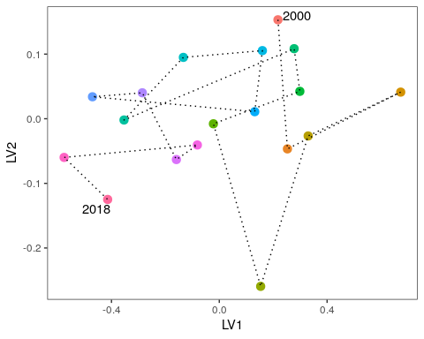

Figure 49 Unconstrained ordination based on invertebrate data for each surveyed year for Lake Melaleuca Park 173. Consecutive years are joined by a line with first and last survey years labeled.

## Melaleuca Park 78

Melaleuca Park 78 (also referred to as EPP 78 or Dampland 78) is located north-west of the Lexia wetlands in the southern area of Melaleuca Park. The site is approximately 6.7 ha in area and represents a regionally significant wetland (Hill et al., 1996). Melaleuca Park 78 is classified as a Dampland habitat, meaning the basin has seasonally waterlogged soils that are not often inundated with surface waters (Semeniuk and Semeniuk, 1996). The site is an important habitat for a unique assemblage of phreatophytic vegetation which provides important habitat for native populations of fauna.

### Hydrology

Water levels at the site have been declining since the beginning of monitoring in 1999 up until 2014, although absolute minimum levels were recorded in 2016. Bore 61613231 indicates that groundwaters in the Dampland may have declined by about 1.3 m since 1999, although there has been a recent increase in groundwater levels since 2016 due to increased rainfall (Figure 50). Current 5 year mean maximum and minimum groundwater levels in the bore are about 1 m lower than when monitoring began in 1999, with peak levels occurring in October/November and minimums occurring between April-May (Table 25).

Groundwater levels have mostly been non-compliant since 2012 after a significant decline from 2009 levels. The effects of reduced abstraction are unlikely to arrest the decline in groundwater levels at this wetland. The proposed threshold is 0.4 m lower than the current threshold. Further declines in groundwater levels are expected by 2030 under a drying climate scenario.

Table 25 Five year summaries of ground water level data Melaleuca Park 78 recorded at bore 61613231.

|  |  |  |  |  |
| --- | --- | --- | --- | --- |
| Period | Mean max seasonal  level (mAHD) | Mean min seasonal  level (mAHD) | Mean seasonal change (m) | Mean max to min (days) |
| 08/1999 – 07/2004 | 66.2 (Oct) | 65.8 (May) | 0.40 | 235 |
| 08/2004 – 07/2009 | 66.0 (Nov) | 65.6 (Apr) | 0.36 | 228 |
| 08/2009 – 07/2014 | 65.4 (Oct) | 65.1 (July) | 0.31 | 213 |
| 08/2014 – 07/2019 | 65.2 (Nov) | 64.9 (May) | 0.29 | 170 |

### Site summary

The current site values are likely to be maintained despite the predicted decreases in groundwater levels at Melaleuca Park 78 (

Table 26). The site will continue to contain a rich native consortium of vegetation that will provide habitat for fauna and important wetland species, such as *M. preissiana*, will persist. There is evidence that the site has recovered substantially from past bushfire events.

Table 26 Ecological consequences of revised thresholds in terms of compliance of stated site management objectives at the Melaleuca Park 78 wetland.

|  |  |  |
| --- | --- | --- |
|  | Likely effect of 2030 revised thresholds | Future Compliance |
| **Site values** |  |  |
| * Supports wetland vegetation | The site is composed of *Banksia* woodland and many groundwater dependent plant species typical of Dampland habitats. Monitoring suggests that the community is relatively stable and has recovered from past fire events. Given the proposed changes in abstraction, it is likely that these species will continue to persist, and the rich native consortium of vegetation will also persist. | Very likely |
| **Site management objectives** |  |  |
| * Maintain wildlife and landscape values of the wetlands | The site will retain the *Banksia* woodlands as a feature and continue to provide habitat to wildlife. | Very likely |
| * Maintain the existing areas of wetlands and wetland vegetation | Some deep-rooted wetland species, such as *Adenanthos cygnorum, which are susceptible to groundwater declines, are predicted to increase in cover abundance given a scenario of low ground water levels. It is likely that the site will retain many of key wetland species, but it is unlikely* B. articulata* will return. | Likely |

### 

### Vegetation dynamics

The vegetation transect has been monitored at Melaleuca Park 78 since 1997 and was last surveyed in 2018 (Buller et al., 2019). The site is largely dominated by native species that include a dense understory of *Beaufortia elegans*, *Pultenea reticulata* and *Kunzea glabrescens*. The overstorey is largely composed of *Melaleuca preissiana* throughout the transect and *Banksia attenuata*, *Banksia ilicifolia* and *Banksia menziesii* in the higher parts of the basin. In 2006, the transect was heavily affected by a fire but the vegetation has since made some recovery. *Baumea articulata* disappeared from the transect during this period. Several tree deaths were reported following the fire but there is evidence of recovery, particularly for low-lying stands of *M. preissiana*. Trajectories of compositional change provide further evidence for post-fire recovery as recent plot assemblages are becoming more similar to those recorded before the fire (Figure 51).

Bayesian regression modelling suggests a number of species associated with low groundwater levels (Figure 52). Some natives, including *B. attenuata*, *Hibbertia subvaginata* and *M. preissiana*, are likely to increase in cover abundance under a scenario of further decreasing groundwaters. The cover abundance of exotics, including *Aira caryophyllea*, *Briza maxima*, *Ehrharta calycina*, *Hypochaeris glabra*, *Poa annua*, *Sonchus oleraceus* and *Ursinia anthemoides*, are also likely to increase in cover abundance with declining groundwaters. Some of the species are groundwater dependent, such as the *Banksia* species, suggesting that despite being in decline, groundwater will remain important in determining the vegetation composition of the wetland It is also likely that the richness of exotic species will increase with groundwater decline as the site becomes invaded by exotics not currently recorded at the site.

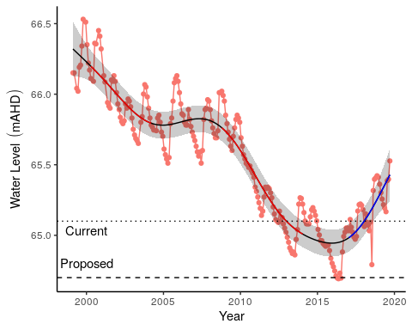

Figure 50 Groundwater levels recorded at bore 61613231 in the vicinity of the Melaleuca Park 78 wetland. Red segments on fitted line represent statistically significant periods of decline and blue represent statistically significant periods of increasing water levels.

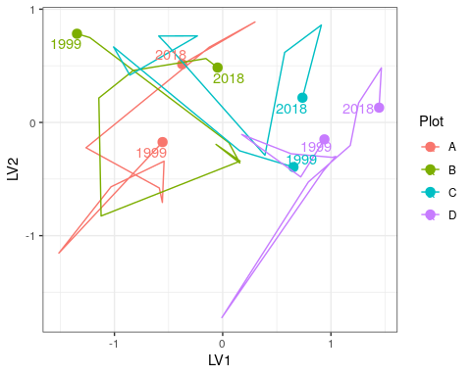

Figure 51 Unconstrained ordination based on the latent variable model for each surveyed year for Melaleuca Park 78. Plots are represented as different colours and consecutive years are joined by a line with first and last survey years labeled.

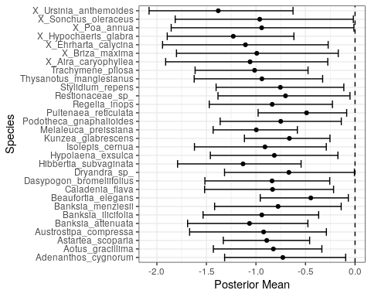

Figure 52 Estimated mean regression coefficients (dots) and 95% credible intervals (bars) for effect of groundwater levels at Melaleuca Park 78 on vegetation species cover abundances based on Bayesian Regression Analysis (HUI REF 2015). Species with a negative mean posterior value are likely to increase in cover abundance as water levels decline. Only those species with coefficients significantly different to zero are shown.

## MM59B - Whiteman Park East

### Hydrology

Groundwater levels at Whiteman Park East have been declining since 1980, although this decline seems to have stabilised since 2010 (Figure 53). Current 5-year mean maximum and minimum water levels are 0.9 and 0.6 m lower than 1994-1999 levels, respectively (Table 27). Minimum water levels occur in June, while maximums are usually reached in October.

Table 27 Five year summaries of surface water level data at Whiteman Park East.

|  |  |  |  |  |
| --- | --- | --- | --- | --- |
| Period | Mean max seasonal  level (mAHD) | Mean min seasonal  level (mAHD) | Mean seasonal change (m) | Mean max to min (days) |
| 08/1994 – 07/1999 | 37.2 (Oct) | 36.2 (Jun) | 1.08 | 229 |
| 08/1999 – 07/2004 | 37.2 (Oct) | 36.1 (Jun) | 1.11 | 244 |
| 08/2004 – 07/2009 | 36.6 (Sep) | 35.8 (Jun) | 0.86 | 244 |
| 08/2009 – 07/2014 | 36.2 (Oct) | 35.5 (Jun) | 0.72 | 249 |
| 08/2014 – 07/2019 | 36.3 (Oct) | 35.6 (Jun) | 0.69 | 249 |

### Site summary

Table 28 Ecological consequences of revised thresholds in terms of compliance of stated site values and site management objectives for MM59B.

|  |  |  |
| --- | --- | --- |
|  | Likely effect of 2030 revised thresholds | Future Compliance |
| **Site values** |  |  |
| * Selected to represent water levels over area of undisturbed phreatophytic vegetation | The site contains some important wetland species, including *Banksia* species, *E. todtiana*, *N. floribunda*, *S. involucrate* and *Calytrix* sp. However, the site is compromised by predation from rabbits and high abundance of exotic species. | Unlikely |
| * Banksia woodland <8m depth to groundwater | *Banksia* woodland appears in good health current low groundwater levels are not causing water stress. Given the proposed threshold will require groundwater levels to be higher than current levels, it is likely that *Banksia* woodland will remain healthy. | Likely |
| **Site management objectives** |  |  |
| * To protect terrestrial vegetation | The high predation from rabbits probably pose the greatest threat to the vegetation currently found at the site. | Possible |

### 

### Vegetation character

The site contains a fairly sparse understory and open mixed woodland canopy consisting of *Banksia* spp., *Allocasuarina fraseriana*, *Nuytsia floribunda* and *Eucalyptus todtiana*. *Banksia* species found at the site include *B. attenuata*, *B. ilicifolia* and *B. menziesii*. Vegetation is slightly degraded with signs of rabbits evident. Species richness and diversity are notably less than some of the other Pinjar sites and more exotic species, such as *Ursinia anthemoides*, are present at high cover abundances. Predominant native understory species include *Scholtzia involucrata*, *Calytrix* spp. and *Patersonia occidentalis*. *Banksia* spp. health was mostly good, although some *B. attenuata* appeared to be approaching senescence, and a number of dead *Banksia* are also present. Recruitment was present but low.

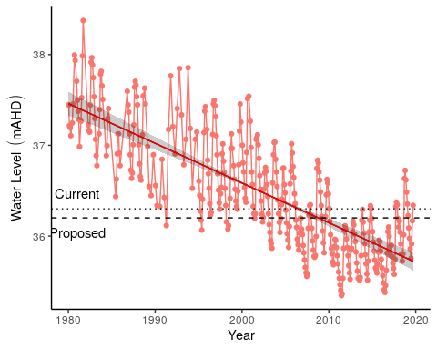

Figure 53 Groundwater levels recorded at bore 61610661 in the vicinity of MM59B. Red segments represent periods of significant decline in groundwater level while blue segments represent periods of significant increase in groundwater level.

## PM9 - Pinjar North

Copied from quote - “Water levels at PM9 have been monitored since 1976 and have fallen approx. 7 meters over this time. It is assumed that vegetation at this site is now no longer able to access groundwater. The nearest vegetation monitoring transect is ‘P50’, located near the Water Corporation’s P50 production bore east of Lake Pinjar, approximately 2.2 km away to the south-west. The P50 transect has been subjected to different influences over the years, including (previous) pumping of the P50 production bore and widespread deaths of vegetation following a succession of high temperatures in the early 1990s, and several fires. There has been an increase in the frequency and cover of species that prefer ‘broad’ site conditions, and an increase in the relative proportion of cover from introduced species. There is a consistent decline on the transect in species preferring excessive wetness.”

WHERE IS VEGETARTION TRANSECT AT P50?

### Hydrology

Groundwater at PM9 have almost continually been in decline since 1980 from approximately 59 mAHD to 2016 levels around 53 mAHD (Figure 54). The most significant rate of decline has been occurring since 1995 to 2016. Maximum and minimal seasonal water levels are 4 and 5 m lower now than in the 1994-1999 period, respectively (Table 29). Since 2016, no measurements at bore 61610804 have been made due to the operation of a nearby rifle range. It is unknown if groundwater levels have continued to decline since 2016 because no measurements have been recorded due to safety concerns regarding access to the bore. If the observed decline has continued, groundwater levels at the site may currently be below 52 mAHD, representing more than a 7 m decline since 1980.

Table 29 Five year summaries of surface water level data at Pinjar North. The final period is based on data up to 2016 only.

|  |  |  |  |  |
| --- | --- | --- | --- | --- |
| Period | Mean max seasonal  level (mAHD) | Mean min seasonal  level (mAHD) | Mean seasonal change (m) | Mean max to min (days) |
| 08/1994 – 07/1999 | 58.4 (Nov) | 57.7 (Jun) | 0.73 | 252 |
| 08/1999 – 07/2004 | 57.5 (Sep) | 56.8 (Jul) | 0.68 | 201 |
| 08/2004 – 07/2009 | 56.5 (Oct) | 56.0 (Jul) | 0.49 | 257 |
| 08/2009 – 07/2014 | 55.2 (Nov) | 54.7 (Sep) | 0.44 | 207 |
| 08/2014 – 07/2016 | 54.4 (Dec) | 52.8 (May) | 1.55 | 242 |

### Site summary

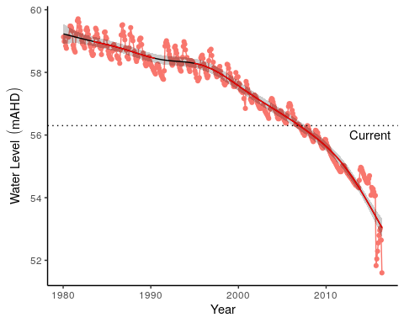

Figure 54 Groundwater levels recorded at bore 61610804 in the vicinity of PM9. Red segments along trendline indicate periods of significant decline in groundwater levels.

## WM1 - Pinjar

WM1 is located east of Lake Pinjar in the Chitty Road Bushland within the Bassendean north vegetation complex. Water levels at WM1 have been non-compliant since 2001.

### Hydrology

Groundwater levels at WM1 have declined up to 4.0 m since 1980, although recent rainfall has increased levels from 54.4 to 55.5 mAHD since 2015 (Figure 55). Current mean maximum and minimum water levels are 2.0 and 1.7 m lower than 1994-1999 levels (Table 30). Maximum water levels generally occur in October and minimum water levels are now occurring later in the year than previously.

Table 30 Five year summaries of surface water level data at Pinjar (WM1).

|  |  |  |  |  |
| --- | --- | --- | --- | --- |
| Period | Mean max seasonal  level (mAHD) | Mean min seasonal  level (mAHD) | Mean seasonal change (m) | Mean max to min (days) |
| 08/1994 – 07/1999 | 57.1 (Nov) | 56.2 (Apr) | 0.95 | 217 |
| 08/1999 – 07/2004 | 56.5 (Oct) | 55.6 (Jun) | 0.86 | 246 |
| 08/2004 – 07/2009 | 55.9 (Oct) | 55.1 (Jul) | 0.81 | 200 |
| 08/2009 – 07/2014 | 54.9 (Oct) | 54.3 (Aug) | 0.54 | 204 |
| 08/2014 – 07/2019 | 55.1 (Oct) | 54.5 (Aug) | 0.57 | 110 |

### Vegetation character

The area has been affected by fire in the past (sometime between early Jan 2015 and late February 2015) and some of the older *Banksias* on the transect have old fire scars. Vegetation structure and community composition of the site is typical *Banksia* woodland, consisting of overstorey species *B. attenuata*, *B. menziesii* and *B. ilicifolia* and a typically diverse dry land understory of *Acacia pulchella*, *Adenanthos cygnorum*, *Jacksonia* spp and *Xanthorrhoea preissii*. Although not recorded in the transect, *Melaleuca preissiana* has been noted nearby. In general, *Banksia* health appears good despite several individuals having significant insect damage and yellow leaves. Previous reports have document the decline of vegetation at this site due to declining groundwater levels (Department of Water, 2008; Water and Rivers Commission, 2004). The trends included a general thinning of the understory, *B. attenuata* deaths, declining condition of *B. ilicifolia* and *B. menziessi*. *Eucalyptus todtiana* and *Corymbia calophylla* have also been reported to be declining in health in 2008 (Department of Water, 2008).

### Site summary

Table 31 Ecological consequences of revised thresholds in terms of compliance of stated site values and site management objectives for WM1.

|  |  |  |
| --- | --- | --- |
|  | Likely effect of 2030 revised thresholds | Future Compliance |
| **Site values** |  |  |
| * Selected to represent water levels over area of undisturbed phreatophytic vegetation |  |  |
| * *Banksia* woodland <8m depth to groundwater |  |  |
| **Site management objectives** |  |  |
| * To protect terrestrial vegetation |  |  |
| * Maintain the existing extent and variety of wetland vegetation |  |  |

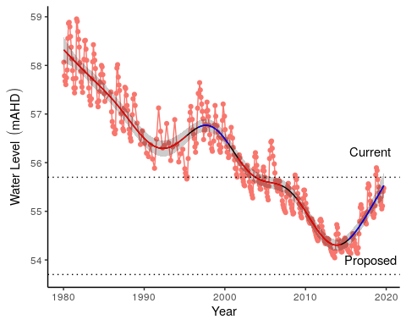

Figure 55 Groundwater levels recorded at bore 61610833 in the vicinity of WM1. Red segments along trendline indicate periods of significant decline in groundwater levels and blue segments represent significant increases in groundwater level.

## WM2 - Melaleuca Park North

Located in Melaleuca Park in the Bassendean north vegetation complex, the area represents an area of undisturbed phreatophytic vegetation, including *Banksia* woodlands (REPORT 82392).

### Hydrology

There has been periods of significant decline in groundwater levels from 68.8 mAHD in 1980 to 66.4 mAHD in 2014 (Figure 56). Since 2015, there has been an increase in groundwater to slightly above 67 mAHD. Mean maximum and minimum seasonal water levels are now 1.5 and 0.9 m lower than the period 1994-1999. Maximum levels have consistently been reached in October, on average (Table 32).

Table 32 Five year summaries of surface water level data at Melaleuca Park North (WM2).

|  |  |  |  |  |
| --- | --- | --- | --- | --- |
| Period | Mean max seasonal  level (mAHD) | Mean min seasonal  level (mAHD) | Mean seasonal change (m) | Mean max to min (days) |
| 08/1994 – 07/1999 | 68.5 (Nov) | 67.6 (Sep) | 0.94 | 216 |
| 08/1999 – 07/2004 | 68.1 (Oct) | 67.4 (Feb) | 0.68 | 246 |
| 08/2004 – 07/2009 | 67.7 (Oct) | 67.1 (Apr) | 0.62 | 205 |
| 08/2009 – 07/2014 | 66.8 (Oct) | 66.4 (Apr) | 0.46 | 210 |
| 08/2014 – 07/2019 | 67.0 (Oct) | 66.5 (Mar) | 0.52 | 79 |

### Site summary

Table 33 Ecological consequences of revised thresholds in terms of compliance of stated site values and site management objectives for WM2.

|  |  |  |
| --- | --- | --- |
|  | Likely effect of 2030 revised thresholds | Future Compliance |
| **Site values** |  |  |
| * Selected to represent water levels over area of undisturbed phreatophytic vegetation |  |  |
| * *Banksia* woodland <8m depth to groundwater |  |  |
| **Site management objectives** |  |  |
| * To protect terrestrial vegetation |  |  |
| * Maintain the existing extent and variety of wetland vegetation |  |  |

### 

### Vegetation character

The vegetation around monitoring bore WM2 has similar vegetation composition as WM1. The vegetation also appears to have been affected by fire in the summer of 2014/2015. The understory is highly diverse, with *Acacia pulchella*, *Adenanthos cygnorum* and *Xanthorrhoea preissii* common. Canopy cover is quite open, with several mature *Banksias* present. Most *Banksias* were resprouts and/or young trees between 1 and 3 m tall. Several mature trees bore significant epicormic growth. New *Banksia* recruitment (mainly very small seedlings) for *Banksia attenuata* and *Banksia menziessi* has been observed.

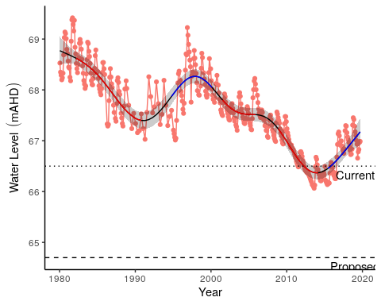

Figure 56 Groundwater levels recorded at bore 61610908 in the vicinity of WM2. Red segments along trendline indicate periods of significant decline in groundwater levels and blue segments represent significant increases in groundwater level.

## WM8 - Melaleuca Park

The WM8 monitoring bore is in Melaleuca Park within the Bassendean north vegetation complex and represents native vegetation that may be affected by abstraction from the Lexia groundwater scheme. There has been no reported change in vegetation at the site, although no monitoring or transects have been established here.

### Hydrology

Groundwater levels began to decline in 2000 at WM8 from approximately 66.0 mAHD to 64.6 mAHD in 2015 (Figure 57). Since 2015, there has been an increase in groundwater levels to approximately 65.5 mAHD. Mean maximum and minimum seasonal water levels have declined by 1.3 and 1.0 m, respectively (Table 34). Maximum levels are generally reached in December while minimum levels are reached in July.

Table 34 Five year summaries of surface water level data at Melaleuca Park (WM8).

|  |  |  |  |  |
| --- | --- | --- | --- | --- |
| Period | Mean max seasonal  level (mAHD) | Mean min seasonal  level (mAHD) | Mean seasonal change (m) | Mean max to min (days) |
| 08/1994 – 07/1999 | 66.3 (Oct) | 65.7 (Jul) | 0.65 | 230 |
| 08/1999 – 07/2004 | 66.0 (Dec) | 65.5 (Jun) | 0.53 | 180 |
| 08/2004 – 07/2009 | 65.6 (Nov) | 65.2 (Jul) | 0.40 | 256 |
| 08/2009 – 07/2014 | 65.0 (Nov) | 64.7 (Aug) | 0.36 | 200 |
| 08/2014 – 07/2019 | 65.0 (Dec) | 64.7 (Jul) | 0.33 | 30 |

### Site summary

Table 35 Ecological consequences of revised thresholds in terms of compliance of stated site values and site management objectives for WM8.

|  |  |  |
| --- | --- | --- |
|  | Likely effect of 2030 revised thresholds | Future Compliance |
| **Site values** |  |  |
| * Selected to represent water levels over area of undisturbed phreatophytic vegetation |  |  |
| * *Banksia* woodland <8m depth to groundwater |  |  |
| **Site management objectives** |  |  |
| * To protect terrestrial vegetation |  |  |
| * Maintain the existing extent and variety of wetland vegetation |  |  |

### 

### Vegetation character

The vegetation community at WM8 is typical of *Banksia* woodland. There is a sparse understory composed predominately of *Lyginia barbata*, *Scholtzia involucrata* and *Eremaea pauciflora*. The canopy is open and consists predominately of *Banksia attenuata* and *B. menziesii*. Tree health at the site was good although several dead mature *Banksias* were present. There is evidence of recent *Banksia attenuata* recruitment, mainly in the form of small seedlings. *Jacksonia floribunda* in notably poorer health than at the other Pinjar sites (WM1 and WM2).

### Ramifications of revised thresholds

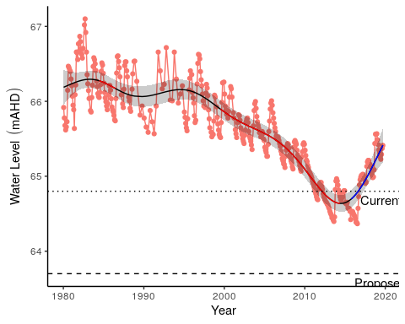

Figure 57 Groundwater levels recorded at bore 61610983 in the vicinity of WM8. Red segments along trendline indicate periods of significant decline in groundwater levels and blue segments represent significant increases in groundwater level.

## Lake Gwelup

Lake Gwelup is a shallow groundwater system located in the highly urbanised area of Gwelup/Karrinyup. The lake is permanently inundated and provides important habitat to a variety of fauna and fringing vegetation. The wetland is not currently a Ministerial criteria site.

### Hydrology

Lake water levels were first monitored in 1960, but regular monitoring has occurred between 1967 and 1988, and from 1999 until the present. Lake levels in the 1970s and 1980s were 1m to 2m higher than in the 2000s (Figure 58). They have risen again since 2013 following a reduction in nearby public water supply abstraction, and levels are currently similar to levels in the 1980s and 1990’s (Table 36). The nearby bore 61610032 has been monitored since 1972. Water levels at the bore have declined by around 4 meters since the start of monitoring. Levels have been reasonably stable since the early 2000s and have trended slightly upwards since 2011.

Table 36 Five year summaries of surface water level data at Lake Gwelup.

|  |  |  |  |  |
| --- | --- | --- | --- | --- |
| Period | Mean max seasonal  level (mAHD) | Mean min seasonal  level (mAHD) | Mean seasonal change (m) | Mean max to min (days) |
| 08/1994 – 07/1999 | 7.5 (Sep) | 5.7 (Apr) | 1.85 | 239 |
| 08/1999 – 07/2004 | 6.7 (Oct) | 5.1 (Apr) | 1.52 | 172 |
| 08/2004 – 07/2009 | 6.3 (Sep) | 5.0 (Dec) | 1.32 | 14 |
| 08/2009 – 07/2014 | 6.1 (Oct) | 5.0 (Jan) | 1.17 | 138 |
| 08/2014 – 07/2019 | 7.3 (Oct) | 5.6 (Apr) | 1.66 | 222 |

### Site summary

Table 37 Ecological consequences of revised thresholds in terms of compliance of stated site management objectives at Lake Gwelup.

|  |  |  |
| --- | --- | --- |
|  | Likely effect of 2030 revised thresholds | Future Compliance |
| **Site management objectives** |  |  |
| * To maintain permanent water for fauna habitat and for visual amenity, to maintain fringing vegetation. |  | Yes |

### 

### Vegetation dynamics

Vegetation monitoring at Lake Gwelup began in 2013 and was last conducted in 2017. The start of the transect was inundated by approximately 0.7 m of surface water during the 2017 survey. The wetland is dominated by exotic species such as *Cynodon dactylon* and *Ehrharta calycina* despite exotic cover abundance declining in the later surveys. The overstorey is dominated by the natives *Eucalyptus rudis* and *Maleleuca rhaphiophyla* which are in good health (Buller et al., 2018). There was a dramatic shift in community composition between 2014 and 2017 due to inundation of the plots (Figure 59). Bayesian regression analysis reveals that a number of exotic species will continue to decrease in cover abundances with the higher water levels (Figure 60).

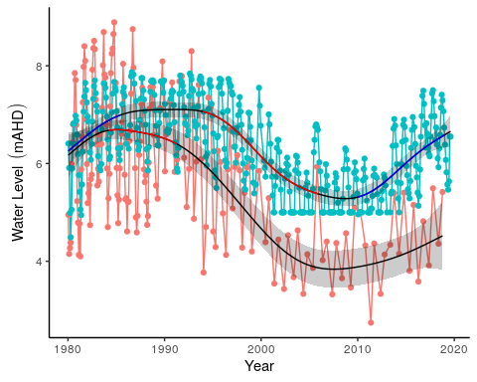

Figure 58 Ground and surface water levels for Lake Gwelup recorded at bore 61610032 (red) and staff 6162504 (blue). The minimum recordable water level for the staff gauge is 5.0 mAHD. Blue dots at 5.0 mAHD represent water levels below the minimum level measurable by the staff. Red segments on fitted line represent statistically significant periods of decline and blue represent statistically significant periods of increasing water levels.

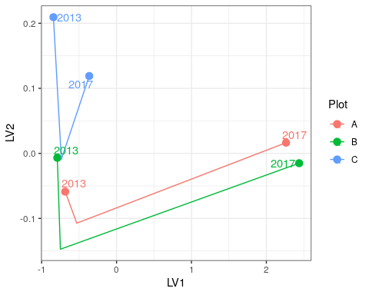

Figure 59 Unconstrained ordination based on the latent variable model for each surveyed year for Lake Gwelup. Plots are represented as different colours and consecutive years are joined by a line with first and last survey years labeled.

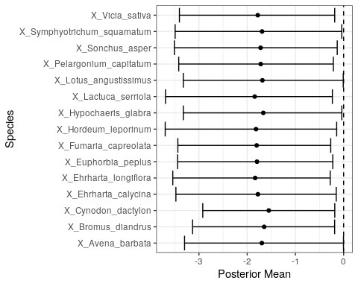

Figure 60 Estimated mean regression coefficients (dots) and 95% credible intervals (bars) for effect of groundwater levels at Lake Gwelup on vegetation species cover abundances based on Bayesian Regression Analysis (HUI REF 2015). Species with a negative mean posterior value are likely to increase in cover abundance as water levels decline. Only those species with coefficients significantly different to zero are shown.

## Quin Brook

Quin Brook is a base flow system where surface flow, riparian vegetation and habitat maintenance all depend on groundwater (R Froend, et al., 2004). The series of interconnected ponds that occur along Quin Brook are of high conservation value because of the pristine nature of the fringing vegetation and the aquatic associated fauna likely to inhabit the surface waters and riparian zones.

### Hydrology

The hydrology of Quin Brook is not well understood. Stretches of the brook are dry most of the year and may have previously been supported by groundwater (Johnson, 2000). Near the confluence with Gingin Brook, flow is maintained throughout the year by groundwater with winter discharge an important source of fill for Lake Yeal (Department of Water, 2011). Groundwater levels at bore 61710060 have been in constant decline since the early 1980’s from approximately 59.5 mAHD to current levels at 53.8 m AHD (Figure 61). Mean maximum and minimum groundwater levels are now nearly 5.0 m below 1994-1999 levels with seasonal patterns almost indistinguishable (Table 38).

Table 38 Five year summaries of surface water level data at Quin Brook.

|  |  |  |  |  |
| --- | --- | --- | --- | --- |
| Period | Mean max seasonal  level (mAHD) | Mean min seasonal  level (mAHD) | Mean seasonal change (m) | Mean max to min (days) |
| 08/1994 – 07/1999 | 59.0 (Jan) | 58.8 (Jul) | 0.26 | 125 |
| 08/1999 – 07/2004 | 58.2 (Jan) | 58.1 (Apr) | 0.16 | 93 |
| 08/2004 – 07/2009 | 57.1 (Oct) | 56.9 (Apr) | 0.25 | 203 |
| 08/2009 – 07/2014 | 55.6 (Nov) | 55.4 (Apr) | 0.14 | 196 |
| 08/2014 – 07/2019 | 54.1 (Oct) | 54.0 (Oct) | 0.11 | 47 |

### Site summary

### Vegetation dynamics

Vegetation at Quin Brook is dominated by some key wetland species, including *Melaleuca rhaphiophyla*, *Eucalyptus rudis*, *Banksia littoralis* and *Melaleuca preissiana*. Vegetation monitoring, which began in 2009, indicates that the *Melaleuca* species have declined significantly in cover abundance to the point where it is no longer present in the higher levels of the transect. Cover abundance of *E. rudis* has remained relatively stable despite the health of individual trees declining (Buller et al., 2019). Other abundant species at the site include *Astartea scoparia*, *Hypocalymna angustifolium* and *Kunzea glabrescens*. All plots along the vegetation monitoring transect have shifted in composition since 2009, mainly due to the decline in *M. rhaphiophyla* and *M. preissiana* (Figure 62). Many species are likely to increase in cover abundances with groundwater level decline, including an exotic grass (probably *Vulpia* sp.), the exotic *Sonchus asper* and *Lotus angustissimus* (Figure 63). Some natives associated with lower groundwater levels include *Senecio* sp., *Pteridium esculentum* and *Hypolaena exsulca*.

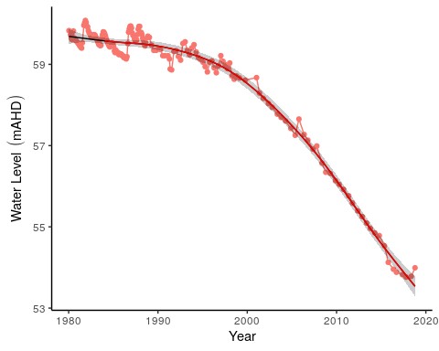

Figure 61 Groundwater levels recorded at bore 61710060 in the vicinity of Quin Brook. Red segments along trendline indicate periods of significant decline in groundwater levels.

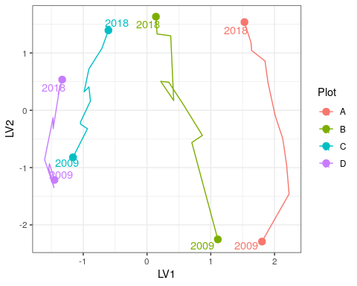

Figure 62 Unconstrained ordination based on the latent variable model for each surveyed year for Quin Brook. Plots are represented as different colours and consecutive years are joined by a line with first and last survey years labeled.

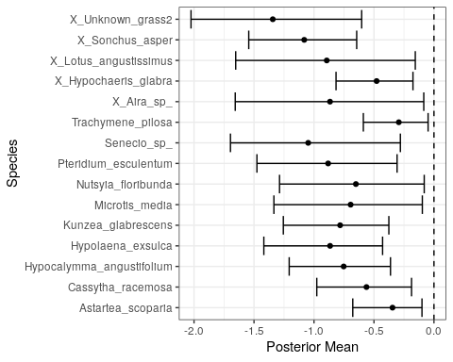

Figure 63 Estimated mean regression coefficients (dots) and 95% credible intervals (bars) for effect of groundwater levels at Quin Brook on vegetation species cover abundances based on Bayesian Regression Analysis (HUI REF 2015). Species with a negative mean posterior value are likely to increase in cover abundance as water levels decline while species with positive values are predicted to increase in cover abundance with water increasing water levels. Only those species with coefficients significantly different to zero are shown.

## Gingin Brook

Gingin Brook is a new proposed site in the Gingin water allocation plan (draft expected 2023). There is currently no baseline vegetation data for the site.

### Hydrology

Groundwaters at this site have significantly declined during the period between 1989 and 2015 by approximately 2.5 m (Figure 64). Mean seasonal maximum and minimum groundwater levels have also decreased by 1.8 since 1994, with current monthly minimums generally occurring earlier in the year than in between 1994 and 1999 (Table 39).

Table 39 Five year summaries of surface water level data at Gingin Brook.

|  |  |  |  |  |
| --- | --- | --- | --- | --- |
| Period | Mean max seasonal  level (mAHD) | Mean min seasonal  level (mAHD) | Mean seasonal change (m) | Mean max to min (days) |
| 08/1994 – 07/1999 | 39.6 (Oct) | 39.2 (Sep) | 0.45 | 219 |
| 08/1999 – 07/2004 | 39.2 (Dec) | 38.6 (Feb) | 0.52 | 198 |
| 08/2004 – 07/2009 | 38.5 (Oct) | 38.1 (Apr) | 0.43 | 213 |
| 08/2009 – 07/2014 | 37.9 (Oct) | 37.5 (Apr) | 0.40 | 221 |
| 08/2014 – 07/2019 | 37.8 (Nov) | 37.4 (Mar) | 0.43 | 141 |

### Site summary

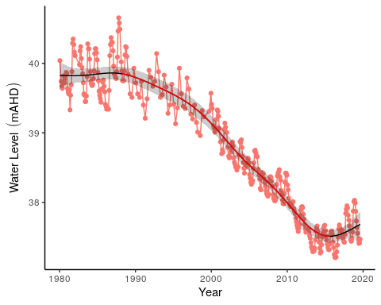

Figure 64 Groundwater levels recorded at bore 61710078 that represent fluctuations in groundwaters at Gingin Brook. Red segments on fitted line represent statistically significant periods of declining groundwater levels.

# Trends across wetlands on the Gnangara Mound

Each wetland monitored in the Gnangara Mound vegetation surveys represent unique assemblages of native vegetation, particularly wetlands such as Melaleuca Park 173, Lake Jandabup and Loch McNess (Figure 65). Generally, the wetlands occurring in the Bassendean Dunes are distinct from those of the Spearwood Dunal System. However, annual monitoring reveals shifts in the composition of these assemblages, with evidence of some wetlands becoming increasingly similar to each other over time, probably in response to changing hydrological regimes. Lexia 186, Melaleuca Park 78 and Quin Brook appear to have vegetation communities with similar shifts in composition, suggesting the drying of these wetlands is a having a common influence on their vegetation structure. Similarly, Lake Mariginiup and Lake Wilgarup, both of which are now experiencing seasonal dry periods, are experiencing dramatic shifts in composition. It is likely that the temporary drying of these once permanent bodies of water is driving similar changes in vegetation composition.

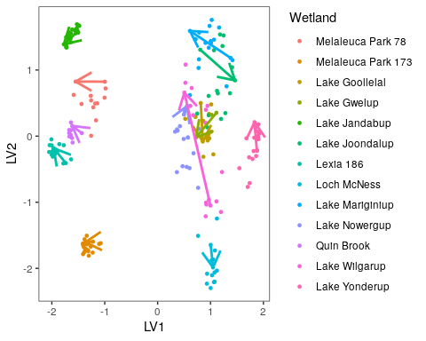

Figure 65 Unconstrained ordination plot of vegetation at each wetland site during the survey period (1996-2018). Arrows represent change from first survey to last survey. Vegetation ordination includes native vegetation only.

The aquatic invertebrate assemblages form three distinct groups based on the dunal system of the wetland (Figure 66). The Spearwood Dunes (Lake Goollelal, Lake Joondalup, Loch McNess, Lake Nowergup and Lake Yonderup) form the most diverse group, while the Bassendean Dunes Wetlands (Melaleuca Park 173) and East Wanneroo Interdunal Wetlands (Lake Jandabup and Lake Mariginiup) have different assemblages to each other. Generally, the Bassendean Dunes and East Wanneroo Interdunal Dunes wetlands are becoming more similar with each other, although such conclusions are based on a very limited set of wetlands. The Spearwood Dunes contain wetlands with two distinct trajectories, those migrating towards initial Lake Joondalup compositions (Loch McNess, Lake Goollelal and Lake Nowergup), and those migrating towards initial Loch McNess compositions (Lake Joondalup and Lake Yonderup). Nonetheless, each wetland has a distinct assemblage of macroinvertebrates but, aquatic macroinvertebrate communities have shifted during the monitoring period. Recent monitoring suggests that Loch McNess and Melaleuca Park 173 are becoming more similar to other wetlands. For instance, Loch McNess has shifted dramatically towards early Lake Joondalup composition. Lake Goollelal has displayed a similar, although not as dramatic, shift in composition. During the monitoring period, it is becoming apparent that Melaleuca Park 173, Lake Jandabup and Lake Mariginiup are converging in terms of macroinvertebrate assemblages. The communities at Lake Joondalup and Lake Yonderup have been shifting towards the early communities of Loch McNess. Lake Nowergup has shown some variation in community composition, but the current trajectory shows little change to the 1996 assemblage.

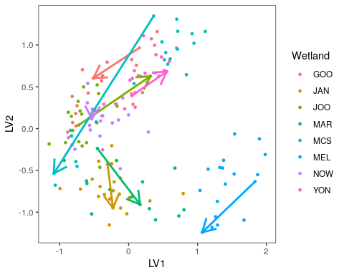

Figure 66 Unconstrained ordination plot of aquatic invertebrates at each wetland site during the survey period (1996-2018). Arrows represent change from first survey to last survey. Vegetation ordination includes native vegetation only. Wetlands included in invertebrate analysis include Lake Goollelal (GOO), Lake Jandabup (JAN), Lake Joondalup (JOO), Lake Mariginiup (MAR), Loch McNess (MCS), Melaleuca Park 173 (MEL), Lake Nowergup (NOW) and Lake Yonderup (YON).

Patterns of changing assemblages and declining richness are complemented by an analysis of monitoring data for macroinvertebrates (Table 40). The limitations of these data are that they are only once-off sampling for the season of spring each year, and only at usually three sites representing three different habitats, so the presence of taxa is a more reliable indicator than the absence of taxa. Nevertheless, patterns are discernible and if repeated over a sequence of years, and if they can be shown at more than one wetland, then they warrant closer attention. For the dataset examined, two patterns were determined. Some taxa were regularly present in the samples, in most years in the early period of monitoring (between 1996 and 2006) but have since become less frequently observed and are now actually absent in the samples in the last 5-15 years). Other taxa were extremely common in the early period of monitoring (between 1996 and 2006) but have since become much rarer or absent in the samples in the last 5-15 years).

Lakes Nowergup, Yonderup and Loch McNess have many taxa in one of these two groups (8, 9 and 10 taxa overall, respectively). Two insect groups have shown the same pattern of decline – Scirtidae beetles (from 4 of the six wetlands) and the Cordulidae damsel flies (also from 4 of the six wetlands). The insects, Corduliidae (Odonata), Ecnomidae (Trichoptera), Haliplidae (Coleoptera) and Mesoveliidae (Hemiptera) are all species with widespread distributions in the Swan Coastal Plain (Sommer et al., 2008), but are now not found in the monitored wetlands reported here.

Table 40 Taxa that have gone from regularly rare to absent and taxa that have gone from common to rare, or absent during spring monitoring.

|  |  |  |
| --- | --- | --- |
| Lake | Taxa that have gone from regularly rare to absent | Taxa that have gone from common to rare or absent |
| Lake Goollelal | Scirtidae (beetle) last seen in 2004 | Hydrophilidae (beetle) last seen 2014 |
| Lake Joondalup | Cordulidae (damsel fly) last seen 2011 |  |
|  | Haliplidae (beetle) last seen 2010 |  |
|  | Scirtidae (beetle) last seen 2010 |  |
| Lake Nowergup | Sphaeridae (bivalve) last seen 2002 | Ceinidae (amphipod) last seen 2007 |
|  | Arrenuridae (mite) last seen 2007 | Notodromadidae (ostracod) last seen 2005 |
|  | Limnesiidae (mite) last seen 2007 |  |
|  | Cordulidae (damsel fly) last seen spring 2011 |  |
|  | Scirtidae (beetle) last seen in spring – 2004 |  |
|  | Chydoridae (Cladoceran) last seen 2011 |  |
| Lake Yonderup | Hirudinea (Leech) last seen 2003 |  |
|  | Ancylidae (limpet) last seen 2011 |  |
|  | Physidae (snail) last seen 2012 |  |
|  | Cordulidae (damsel fly) last seen spring 2008 |  |
|  | Lestidae (damsel fly) last seen spring 2006 |  |
|  | Libellulidae (damsel fly) last seen spring 2005 |  |
|  | Mesovelidae (bug) last seen 2006 |  |
|  |  |  |
|  | Dytiscidae (beetle) last seen 2014 |  |
|  | Macrothricidae (cladoceran) last seen 2013 |  |
| Loch McNess | Limnesiidae (mite) last seen 2007 | Palaemonidae (shrimp) last seen 2010 |
|  | Oxiidae (mite) last seen 2008 | Hydroptilidae (purse caddis) last seen 2014 |
|  | Unioncolidae (mite) last seen 2006 |  |
|  | Parastacidae (crayfish) last seen 2003 |  |
|  | Caenidae (mayfly) last seen 2010 |  |
|  | Simuliidae (blackfly) last seen 2003 |  |
|  | Calanoida (zoopl.) last seen 2009 |  |
|  | Macrothricidae (cladoceran) last seen 2007 |  |

# Summary

## Overview

Summary table (

Table 41).

Table 41 Summary of ecological consequences of revised thresholds in terms of compliance of stated site values and site management objectives at wetlands on Gnangara Mound.

|  |  |  |  |
| --- | --- | --- | --- |
| Wetland | Current Threshold (mAHD) | Proposed Threshold (mAHD) | Ecological consequences |
| Lake Goollelal | 26.0 | 26.4 | The lake will remain permanently inundated at similar levels as present. Fringing vegetation will persist and provide habitat for the current diversity of aquatic invertebrates. The site will continue acting as a drought refuge for water birds and provide important habitat to important native fish species. |
| Loch McNess | 6.95 | 6.20 | Declines in groundwater have caused major shifts in vegetation and aquatic invertebrate communities. In particular, the unique assemblage of macroinvertebrates present within the lake has been replaced by common taxa and nuisance species. Declining water levels have also caused the disappearance of *B. articulata*, an important fringing macrophyte. Declining water levels have also caused significant increases in nutrient levels and sustained low water levels are likely to have serious consequences for an important population of Rakali. Under the revised abstraction plans, these ecological shifts are likely to persist into the future and typical characteristics and ecological processes once a feature of the system before the 2003 water level decline will not return. |
| Lake Yonderup | 5.9 | 5.7 | The stable hydrological regime is not likely to return to this wetland if the wetland remains non-compliant with the current ministerial threshold. Nonetheless, the aquatic macroinvertebrate community has remained relatively stable in composition, a feature likely to persist if further declines do not occur. Further declines in water level before 2028 may cause significant changes in water quality, especially nitrogen levels, which may impact aquatic invertebrate communities before the revised thresholds are applicable. Higher water levels than current (approximate minimum levels of 5.5 mAHD) may have beneficial effects for surrounding *Banksia* woodland and fringing vegetation. |
| Lake Joondalup | 15.8 | 16.2 | The proposed thresholds will see water levels maintained at levels higher than current levels. This will have a positive impact for fringing sedge vegetation and fish and bird habitat. There is the possibility that terrestrial vegetation occurring at higher elevations in the basin, may be squeezed as further migration up-slope become hampered by surrounding urbanisation. Nutrient enrichment remains an issue for the lake and further increases in nutrient levels may cause a shift in ecological processes and change the character of the lake. |
| Lake Mariginiup | 41.5 | 42.1 | The predicted increases in water levels may be sufficient to halt acidification of the lake. It is possible to restore the water quality of the lake, but this requires the sediments to have sufficient capacity to buffer the acidification once re-wetted. Nonetheless, if acidification cannot be reversed, the current assemblage of macro-invertebrates is likely to persist. The proposed changes to groundwater levels will enhance the extent of habitat available to wading birds and, over a period of decades, restore *E. rudis* woodland. Given the decline in water level and the acidification that has occurred, it is unlikely that the native fish *P. olorum* is locally extinct from the lake and will not return unless water quality is restored and it is able to immigrate back to the lake. |
| Lake Jandabup | 44.3 | 44.3 | Acidification is currently causing a decrease in richness of the aquatic macroinvertebrate communities, and the proposed changes in water level are not likely to affect this process. Otherwise, the predicted increases in surface water levels will have a beneficial effect on native vegetation, sedges and wader bird habitat. Elevated nutrient levels may continue to remain a concern. |
| Lake Nowergup | 16.8 | 16.0 | Declining surface water levels at this wetland are going to contribute further to the ecological decline of this wetland. Areas of wetland vegetation are very likely to become terrestrialised, while the extent of existing sedge vegetation is going to be greatly reduced. The capacity of this wetland to act as a drought refuge for birds will be diminished and habitat for native fish species will be at increased risk of disappearance. |
| Lake Wilgarup | 4.5 | 3.9 | Lake Wilgarup, as a wetland, has been severely compromised by a combination of declining groundwater levels and fire. The site no longer resembles a wetland and is dominated by terrestrial woodland vegetation. The proposed changes to groundwater level are unlikely to prevent further terrestrialisation of this site. |
| Pipidinny Swamp | 1.6 | 1.1 | Aquatic macroinvertebrate communities have been seriously compromised at Pipidinny Swamp due to falling water levels. Although the proposed changes to abstraction may cause water levels to be managed at levels higher than currently exists, this state will be much lower than pre-2000 levels. The proposed changes to abstraction are unlikely restore the aquatic macroinvertebrate communities to what was once typical of the swamp, and exotic plants will remain a feature of the vegetation community. Nonetheless, fringing vegetation is likely to persist and continue to provide habitat for aquatic fauna. |
| Lexia 186 | 47.2 | 46.5 | A significant shift in hydrological regime has occurred at Lexia 186. The site has been transformed from a seasonally waterlogged Dampland to a system where saturation of surface sediments no longer occurs. Despite the declining ground water levels, shifts in vegetation composition are likely to be driven by other processes. The site has retained the high richness of native species and is still an important habitat for fauna. The proposed changes to the threshold are likely to maintain the system at a state that currently exists. |
| Melaleuca Park 173 | 50.2 | 48.5 | The proposed threshold will see the wetland managed in a state similar to what currently exists. The wetland has shifted from a permanently inundated wetland to a seasonally inundated dampland, hence there has been shifts in vegetation and aquatic fauna. The site is no longer provides habitat to the fish species, an important value of the wetland. Fringing vegetation is likely to continue shifting in composition as key wetland species are lost and more terrestrial species migrate down-slope. The aquatic fauna is likely to persist with much less diversity as available habitats are diminished and change. |
| Melaleuca Park 78 | 65.1 | 64.7 | Despite the dramatic declines in groundwater, the site still retains a high richness of native vegetation species. Some wetland species have disappeared, notably *B. articulata*, however, it is predicted that many key wetland species will remain at the site despite the predicted declines in groundwater levels under the planned abstraction changes. The proposed threshold will retain many of the values that currently exist at the site. |
| MM59B - Whiteman Park East | 36.3 | 36.2 | No long-term vegetation monitoring exists at this site. Current vegetation is impacted by predation from rabbits and despite the declining groundwater levels, the vegetation appears in good health. The proposed threshold will require water levels to be substantially higher than current levels, suggesting the health of the woodland will persist. |
| PM9 - Pinjar North | 56.3 |  |  |
| WM1 - Pinjar | 55.7 | 53.7 |  |
| WM2 - Melaleuca Park North | 66.5 | 64.7 |  |
| WM8 - Melaleuca Park | 64.8 | 63.7 |  |
| Lake Gwelup |  |  |  |
| Quin Brook |  |  |  |
| Gingin Brook |  |  |  |

## 

## Management objectives

## Conclusions

# References

Bamford, M.J., Bamford, A.R., 2003. Vertebrate Fauna: Valuesand Groundwater Dependence in the Gnangara Study Area. Water; Rivers Commission, Perth, Western Australia.

Buller, G., Kavazos, C.R.J., Froend, R., 2019. Wetland Vegetation Monitoring 2018 Survey of Gnangara Wetlands. Edith Cowan Univeristy, Joondalup.

Buller, G., Kavazos, C.R.J., Froend, R., 2018. Wetland Vegetation Monitoring 2017 Survey of Gnangara Wetlands. Edith Cowan University, Joondalup.

Department of Water, 2011. Groundwater-surface water interaction along Gingin Brook Western Australia (No. January). Government of Western Australia.

Department of Water, 2008. Review of ministerial conditions on the groundwater resources of the Gnangara Mound (No. January). Department of Water, Perth, Western Australia.

England, M.H., Ummenhofer, C.C., Santoso, A., 2006. Interannual rainfall extremes over southwest Western Australia linked to Indian Ocean climate variability. Journal of Climate 19, 1948–1969. <https://doi.org/10.1175/JCLI3700.1>

Froend, R., Loomes, R., Horwitz, P., Bertuch, M., Storey, A., Bamford, M., 2004. Study of Ecological Water Requirements on the Gnangara and Jandakot Mounds under Section 46 of the EP Act. Task 2: Determination of Ecological Water Requirements (No. September). Centre for Ecosystem Management, Edith Cowan University, Perth, Western Australia.

Froend, R., Loomes, R., Horwitz, P., Rogan, R., Lavery, P., How, J., Storey, A.W., Bamford, M., Metcalf, B., 2004. Study of Ecological Water Requirements on the Gnangara and Jandakot Mounds under Section 46 of the EP Act. Task 1: Identification and Re-valuation of Ecological Values. Centre for Ecosystem Management, Edith Cowan University, Joondalup, Western Australia.

Groom, P.K., Froend, R.H., Mattiske, E.M., 2000. Impact of groundwater abstraction on a Banksia woodland, Swan Coastal Plain, Western Australia. Ecological Management & Restoration 1, 117–124.

Heddle, E.M., Loneragan, D.W., Havel, J.J., 1980. Vegetation complexes of the Darling System, Western Australia. Atlas of natural resources, Darling System, Western Australia. Department of Conservation an Environment, Perth.

Hill, A.L., Semeniuk, C.A., Semeniuk, V., Marco, A.D., 1996. Wetland Mapping, Classification and Evaluation, Main Report, in: Wetlands of the Swan Coastal Plain. Perth, Western Australia.

Horwitz, P., Bradshaw, D., Hopper, S., Davies, P., Froend, R., Bradshaw, F., 2008. Hydrological change escalates risk of ecosystem stress in Australia’s threatened biodiversity hotspot. Journal of the Royal Society of Western Australia 91, 1–11.

Horwitz, P., Sommer, B., Froend, R., 2009. Wetlands and groundwater dependent ecosystems of the Gnangara Mound, in: Gnangara Sustainability Strategy. Centre for Ecosystem Managment, Edith Cowan University, Joondalup, Western Australia, pp. 1–48.

Hui, F.K., 2016. boral – Bayesian Ordination and Regression Analysis of Multivariate Abundance Data in r. Methods in Ecology and Evolution 7, 744–750. <https://doi.org/10.1111/2041-210X.12514>

Hui, F.K.C., 2018. boral: Bayesian Ordination and Regression AnaLysis.

Johnson, S.L., 2000. Hydrogeological assessment of the perennial brooks on the Dandaragan Plateau. Water; Rivers Commission, Perth, Western Australia.

Judd, S., Horwitz, P., 2019. Annual Report for the Gnangara Mound Environmental Monitoring Programme - Macroinvertebrate and Water Quality Wetland Monitoring for Spring 2018. Edith Cowan University, Joondalup, Perth.

McArthur, W.M., Bettenay, E., 1960. The development and distribution of the soils of the Swan coastal plain, Western Australia., Second. ed. Commonwealth Scientific; Industrial Research Organisation, Australia, Melbourne.

Muler, A.L., Canham, C.A., Etten, E.J.B.V., Stock, W.D., Froend, R.H., 2018. Forest Ecology and Management Using a functional ecology approach to assist plant selection for restoration of Mediterranean woodlands. Forest Ecology and Management 424, 1–10. <https://doi.org/10.1016/j.foreco.2018.04.032>

Pinheiro, J., Bates, D., DebRoy, S., Sarkar, D., R Core Team, 2019. nlme: Linear and Nonlinear Mixed Effects Models.

Quintero Vasquez, M., Lund, M.A., 2018. Yellagonga Regional Park wetlands water quality monitoring 2017/18 report. Center for Ecosystem Management, Edith Cowan Univerisity, Perth, Australia.

Rogan, R., Loomes, R., Froend, R., 2006. Wetland vegetation monitoring 2005 - survey of Gnangara Wetlands. Centre for Ecosystem Managment, Edith Cowan University, Joondalup, Western Australia.

Salama, R.B., Bekele, E., Hatton, T., Pollock, D., Lee-Steere, N., 1991. Sustainable yield of groundwater of the Gnangara Mound, Perth, Western Australia 1–21.

Semeniuk, C.A., Semeniuk, V., 1996. The geomorphic classification of wetlands, in: Hill, A.L., Semeniuk, C.A., Semeniuk, V., Marco, A.D. (Eds.), Wetlands of the Swan Coastal Plain. Perth, Western Australia, pp. 30–49.

Sommer, B., Horwitz, P., 2009. Macroinvertebrate cycles of decline and recovery in Swan Coastal Plain (Western Australia) wetlands affected by drought-induced acidification. Hydrobiologia 624, 191–203. <https://doi.org/10.1007/s10750-008-9692-6>

Sommer, B., Horwitz, P., Hewitt, P., 2008. Assessment of Wetland Invertebrate and Fish Biodiversity for the Gnangara Sustainability Strategy (GSS) (No. November). Centre for Ecosystem Management, Edith Cowan University, Joondalup, Western Australia.

Water and Rivers Commission, 2004. Environmental management of groundwater abstraction from the Gnangara Mound 2000-2003 - Triennial report to the Environmental Protection Authority. (No. March). Water; Rivers Commission, Perth, Western Australia.

Water Authority of Western Australia, 1995. Review of proposed changes to environmental conditions: Gnangara Mound groundwater resources (Section 46) / Water Authority of Western Australia. Water Authority of Western Australia, Leederville, W.A.

Wood, S., 2019. mgcv: Mixed GAM Computation Vehicle with Automatic Smoothness Estimation.

Wood, S.N., 2011. Fast stable restricted maximum likelihood and marginal likelihood estimation of semiparametric generalized linear models. Journal of the Royal Statistical Society. Series B: Statistical Methodology 73, 3–36. <https://doi.org/10.1111/j.1467-9868.2010.00749.x>

Yesertener, C., 2007. Assessment of the declining groundwater levels in the Gnangara Mound, Report HG1. ed. Perth, Western Australia.

Zencich, S.J., Froend, R.H., Turner, J.V., Gailitis, V., 2002. Influence of groundwater depth on the seasonal sources of water accessed by Banksia tree species on a shallow, sandy coastal aquifer. Oecologia 131, 8–19. <https://doi.org/10.1007/s00442-001-0855-7>